  2017 |  | 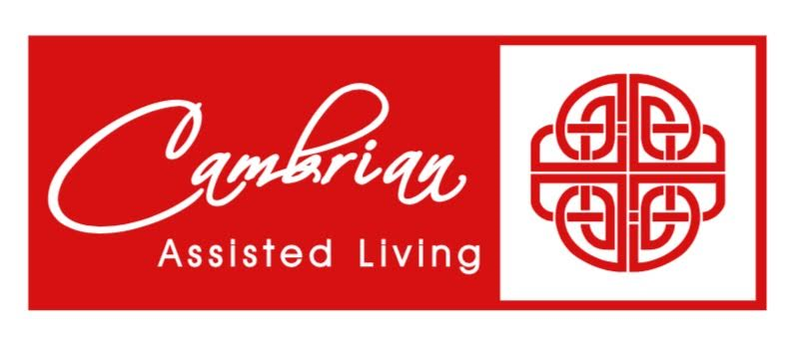 |  | Like” us on Facebook at: Cambrian Senior Living, Tecumseh    Beauty Salon/ Barber Shop/  Manicures by Appointment | 1  9:00 Balance Class  10:00 Health Matters: The Importance of Exercise  11:00 Sunshine Committee/ Cookie Club  1:00 Helen’s Piano  2:00 Community Euchre  4:00 Happy Hour  6:00 Rummy | 2 Podiatry  11:00 Exercise Ball  1:00 Piano with Jim  2:00 Dominoes  3:00 Faces and Places  6:00 Evening Movie: Mrs.> Dougtfire | 3  9:00 Walking Club  1:30 Bingo  6:00 Euchre & Guest
4  9:30 Catholic Communion  3:00 Worship Service  6:00 Euchre | 5  9:00 Life Enrichment Committee Meeting  9:30 Summer Sing  12:30 Tecumseh Library:  Remembering Civil War Soldiers at Monument Park  3:00 Courtyard Club  6:00 Mixed Cards |  | 6  9:00 Lutheran Communion Service  9:00 Trip to Busch’s  10:30 Poetry Out Loud: Emily Dickenson  2:00 Floral Design, Canasta & Dominos  6:00 Brain Games/ Color Creations | 7 Beauty Shop  9:00 Exercise Ball  10:00 Welcome the Month of June  11:00 Menu Planning  2:00 Wii Bowling/ Cookie Club  6:00 Resident Choice | 8 Beauty Shop  9:00 Passport for Wellness  10:00 Food Committee  11:00 Lutheran Service  1:00 Helen’s Piano  2:00 Community Euchre  4:00 Happy Hour  6:00 Rummy | 9  9:00 Exercise Ball  10:00 YouTube & You  1:00 Piano with JIm  2:00 Dominoes  3:00 Cranium Crunches  6:00 Evening Movie: Father of the Bride | 10  9:30 Tour of Tecumseh Trolley Ride: Reserve your tickets  1:30 Bingo  6:00 Euchre & Guest
11  9:30 Catholic Communion  4:00 Hymn Sing  6:00 Euchre | 12 Manicures  9:00 Balance Class  10:00 Cookie Club  10:45 Chinese Lunch Outing  2:00 Card Shark  3:00 Courtyard Club  6:00 Mixed Cards |  | 13  9:30 Trip to Busch’s  10:30 Resistance Training  2:00 Floral Design/ Canasta  & Dominoes  3:00 Pet Therapy/Mugsey  3:00 Gypsy Social with Special Music & Refreshments  6:00 Brain Games/ Color Creations | 14 Beauty Shop  9:00 Devotion Bill Face  10:15 Exercise Ball  11:00 Menu Planning  2:00 Wii Bowling / Walking Club  6:00 Resident Choice | 15 Beauty Shop  9:00 Zumba Gold  10:00 Resident Council  1:00 Helen’s Piano  2:00 Community Euchre  4:00 Happy Hour  6:00 Rummy | 16 Kat off  9:00 Exercise Ball  10:15 Bible Study/ Tom  1:00 Drum Circle  2:00 Dominoes  6:00 Evening Movie: My Big Fat Greek Wedding | 17  9:00 Donuts with Dad  1:30 Bingo  6:00 Euchre & Guest
18  9:30 Catholic Communion    4:00 Hymn Sing  6:00 Euchre | 19  9:00 Jazz It Up, Exercise  10:30 Let’s Talk Baseball: Willie May  1:30 Art Appreciation  3:00 Courtyard Club  6:00 Mixed Cards |  | 20  9:00 Trip to Busch’s  11:00 Mindful Meditation  1:00 Dorothy’s Piano  2:00 Floral Design/ Canasta  2:00 Welcoming Committee  4:00 Hall Hikers  6:00 Brain Games/ Color Creations | 21 Beauty Shop  9:00 Exercise Ball  10:30 Picnic Outing  11:00 Menu Planning  2:00 Wii Bowling /Walking Club  6:00 Resident Choice | 22 Beauty Shop  9:00 Passport to Wellness  11:00 Lutheran Services  1:00 Helen’s Piano  2:00 Community Euchre  4:00 Happy Hour  6:00 Rummy | 23  9:00 Exercise Ball  10:00 YouTube & You  1:00 Piano with Jim  2:00 Dominoes  6:00 Evening Movie: For the Love of the Game | 24  9:00 Walking Club  1:30 Bingo  6:00 Euchre & Guest
25  9:3 Catholic Communion  3”00 Worship Service  6:00 Euchre | 26 Manicures Barber Shop  9:00 Passport to Wellness  10:30 Courtyard Club  3:00 Nickle Bingo  6:00 Mixed Cards |  | 27  9:00 Trip to Busch’s  11:00 Mindful Meditation  2:00 Floral Design / Canasta  4:00 Hall Hikers  6:00 Brain Games/ Color Creations | 28 Beauty Shop  10:30 Mudd Hen’s Game: Please sign up, Tickets Limited  11:00 Menu Planning  2:00 Wii Bowling /Walking Club  4:00 Picnic Prep  6:00 Resident Choice | 29  12:00 Summer Cookout  1:00 Helen’s Piano  2:00 Community Euchre  3:30 Dixie Land Band  4:00 Happy Hour  6:00 Rummy | 30  9:00 Exercise Ball  1:00 Piano with Jim  2:00 Dominoes  3:00 Faces and Places  6:00 Evening Movie: Grumpy Old Man | Please see our daily sheets for addition information or change in time or events.  Activities and times subject to change,

SUNDAY MONDAY TUESDAY WEDNESDAY THURSDAY FRIDAY SATURDAY

