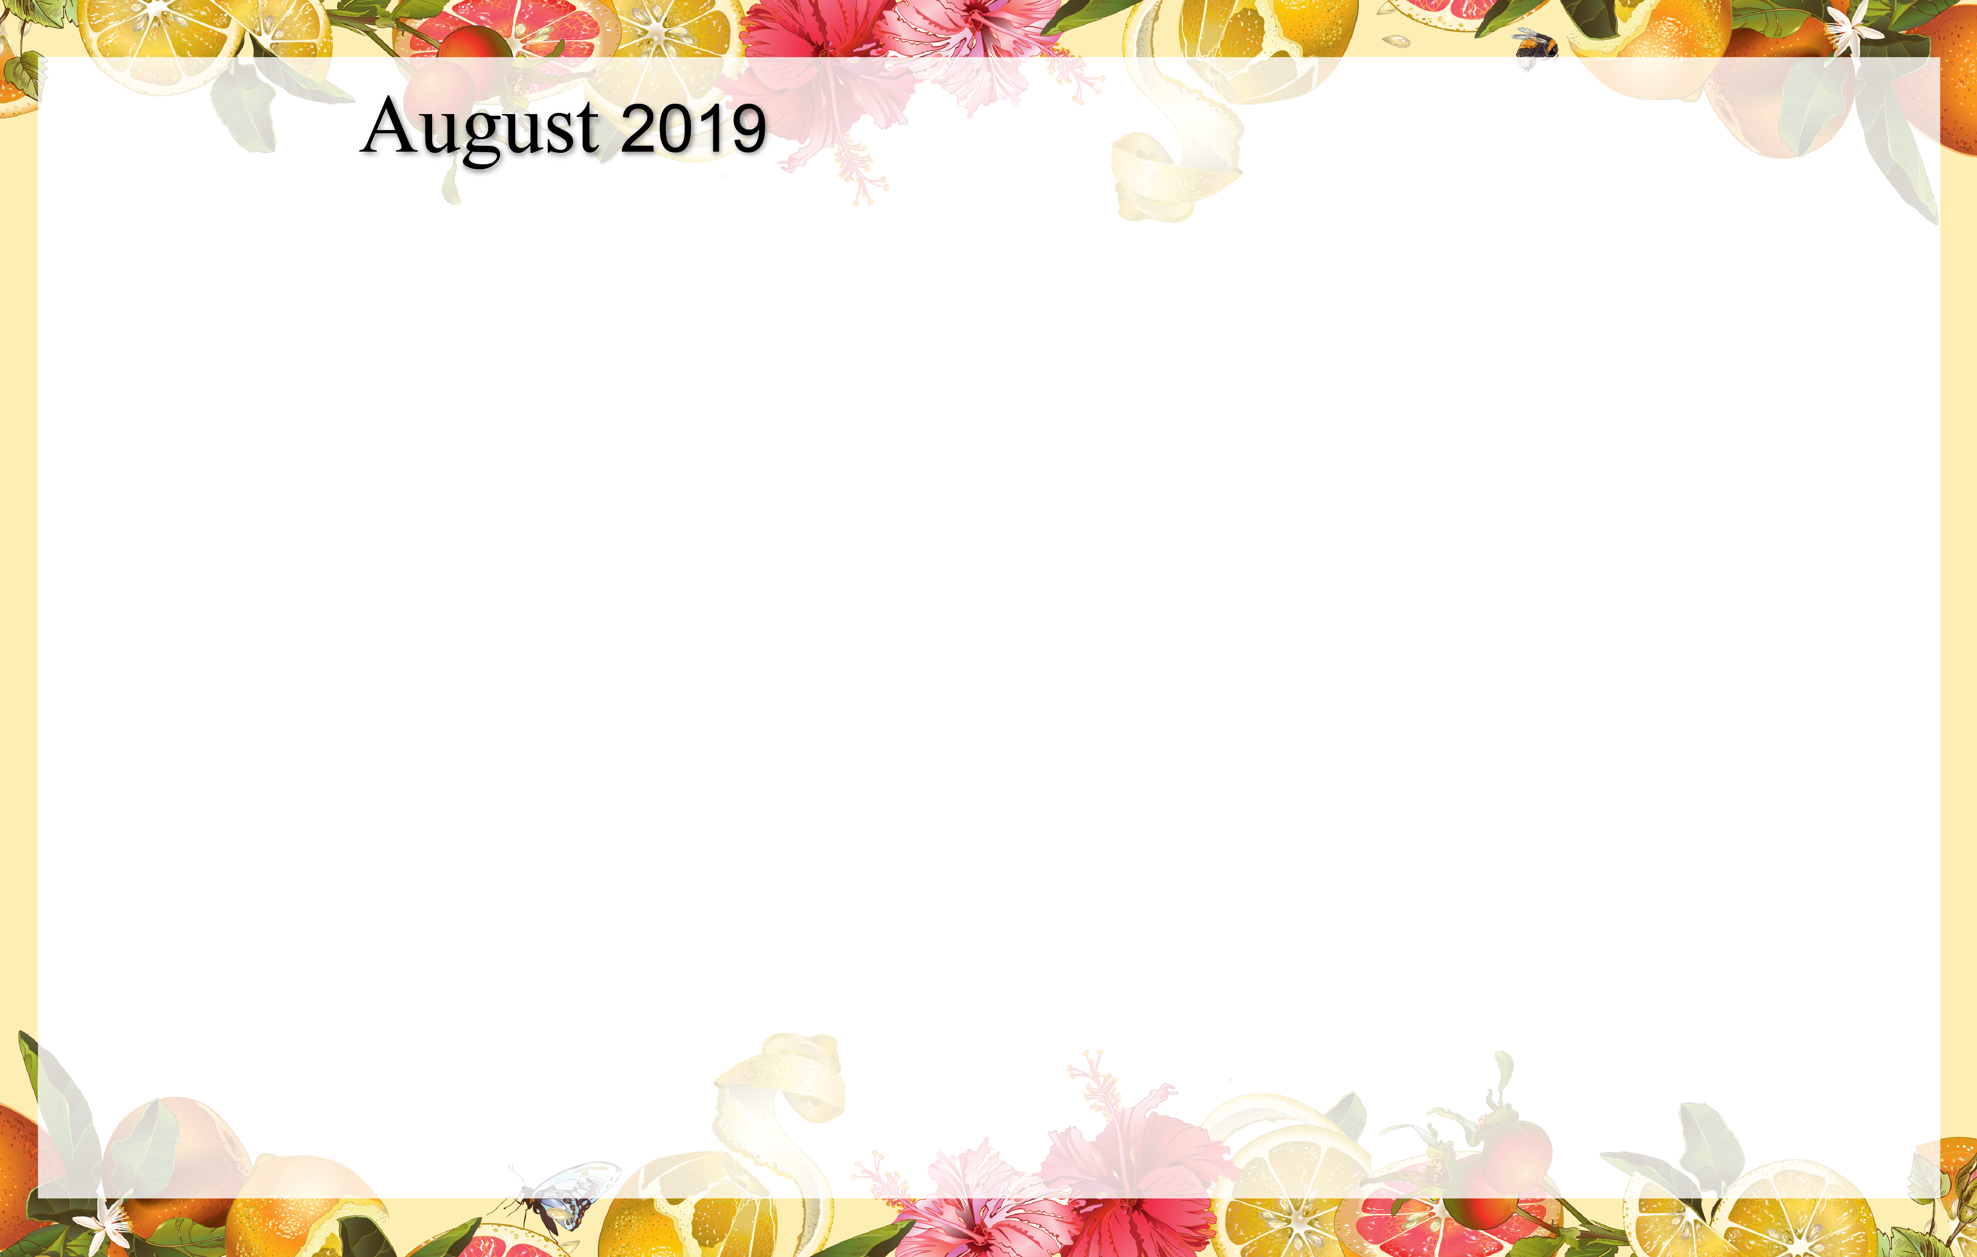
-
 |  |  | Birthday’s this month  Mary Ellen 8/15  Rosemary 8/18  Virginia 8/28  Dee 8/31 | 1 Beauty Shop  9:00 Basketball  10:00 Resident Council  11:00 E Z Does it  1:00 Shuffleboard  4:00 Happy Hour | 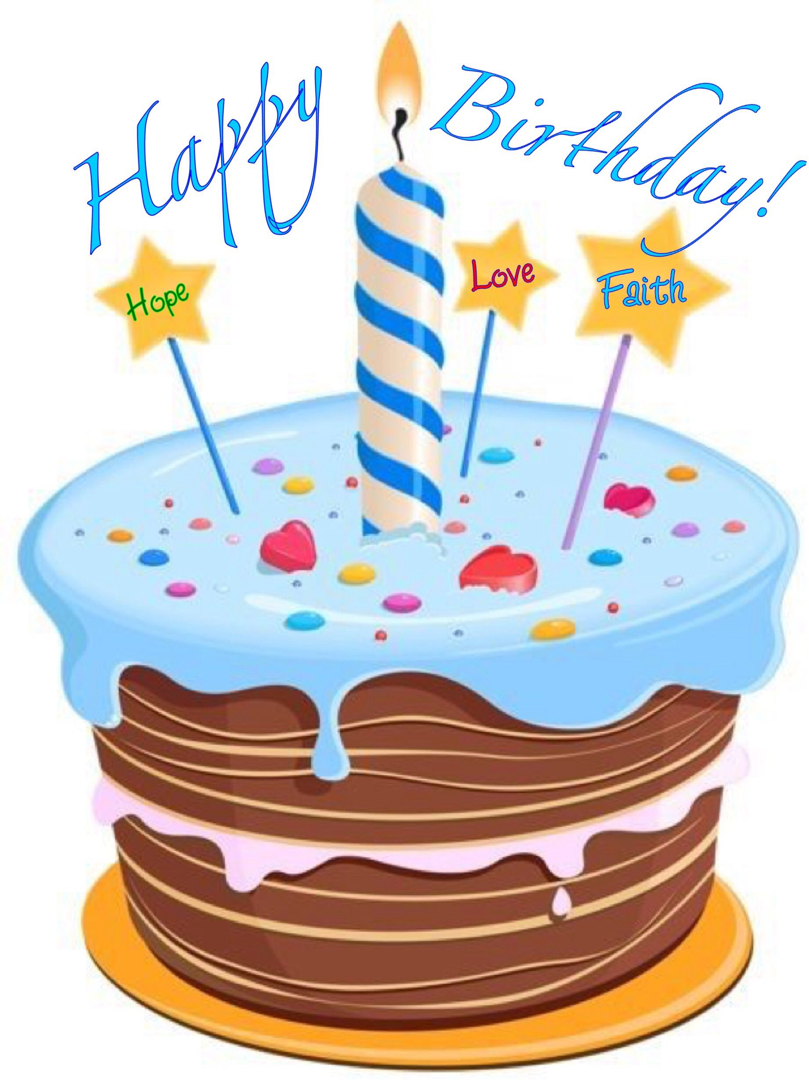  2 Twin day  Ice Cream sandwich day  9:00 Hall Hikers & Daily  Chronicle  1:00 Craft Hour  4:00 Courtyard Ice  Cream Social | 3  9:00 Basketball & Daily  Chronicle  1:30 Worship Service  3:00 Trivia Hour
4  9:30 Catholic  Communion  1:00 Activity Room  Games  3:05 Tigers Baseball | 5  9:00 Chair Pilates  9:30 Daily Chronicle  1:00 Bingo  2:00 Craft Hour  4:00 Music & Prayer | 6  9:00 Noodle Ball Sports  10:00 Catholic Mass  1:00 Wii Bowling  1:10 Tigers Baseball  4:00 Happy Hour &  root beer floats | 7  10:00 Morning Exercise  11:00 Kroger Trip  1:00 Wii Bowling  1:10 Tiger Baseball  3:00 Piano Phenom  Steven Mullan | 8 Beauty Shop  9:00 Bean Bag Toss  9:30 Daily Chronicle  11:30 Cambrian Picnic  1:00 Shuffleboard  4:00 Happy Hour | 9 Kool-aid day  9:00 Target Practice  9:30 Daily Chronicle  1:15 Drum Circle  4:00 Craft Hour | 10  9:00 Noodle Sports  1:30 Worship Service  3:00 Shuffleboard  6:10 Tigers Baseball
11  9:30 Catholic  Communion  1:00 Activity Room  Games  1:10 Tigers Baseball | 12  9:00 Chair Pilates  9:30 Daily Chronicle  1:00 Bingo  4:00 Travelogue | 13 Left handers day  9:00 Cardio Crunch  9:30 Daily Chronicle  1:00 Craft Hour  4:00 Happy Hour | 14 Gorp day  10:15 Catholic Communion  11:00 Kroger Trip  1:00 Wii Bowling  1:10 Tigers Baseball  4:00 Music & Prayer | 15 Beauty Shop  9:00 Music & Motion  9:30 Daily Chronicle  1:00 Penny Auction  1:10 Tigers Baseball  4:00 Happy Hour | 16 Klondike Bar Day  9:00 Hall Hikers  4:00 Trivia  8:10 Tigers Baseball | 17  9:00 Trivia & Daily  Chronicle  1:30 Worship Service  3:00 Afternoon exercise  7:10 Tigers Baseball
18  9:30 Catholic  Communion  1:00 Activity Room  Games  1:10 Tigers Baseball | 19  9:00 Chair Pilates  9:30 Daily Chronicle  1:00 Bingo  4:00 Short Story | 20 Putting/Golf Day  9:00 Balance Class  9:30 Daily Chronicle  1:00 Putting Tournament  4:00 Happy Hour | 21 Sr. Citizens Day  10:15 Catholic Communion  11:00 Music & Worship w/Jo  11:00 Kroger Trip  1:00 Wii Bowling  4:00 Courtyard Conversation | 22 Beauty Shop  9:00 Bean Bag Toss  10:30 Book Club  1:00 Shuffleboard  4:00 Happy Hour | 23  9:00 am  Island Queen Boat Ride &  Breakfast Outing  1:00 Craft Hour  4:00 Trivia  7:05 Tigers baseball | 24 Potato chip day  9:00 Noodle Ball  1:30 Worship Service  4:00 Piano Performance  6:10 Tigers Baseball
25  9:30 Catholic  Communion  1:00 Activity Room  Games  2:10 Tigers Baseball | 26  9:00 Chair Pilates  10:00 Daily Chronicle  1:00 Bingo  4:00 Google Earth Travel | 27  9:00 Morning Movement &  Daily Chronicle  10:00 Trivia Hour  Noon Lunch w/LE  1:00 Dominos  4:00 Happy Hour  7:10 Tigers Baseball | 28 Wear White  Wednesday  10:15 Catholic Communion  11:00 Kroger Trip  1:00 Wii Bowling  1:10 Tigers Baseball  4:00 Music & Prayer | 29 Beauty Shop  9:00 Music & Motion  10:00 Cambrian Store  1:00 Out and About  4:00 Happy Hour  7:05 Tigers Baseball | 30  9:00 Hall Hikers  9:30 Trivia  1:00 Drums Alive  4:00 Friday Bingo | 31  9:00 Basketball &  Daily Chronicle  1:30 Worship Service  3:00 Movie & Popcorn
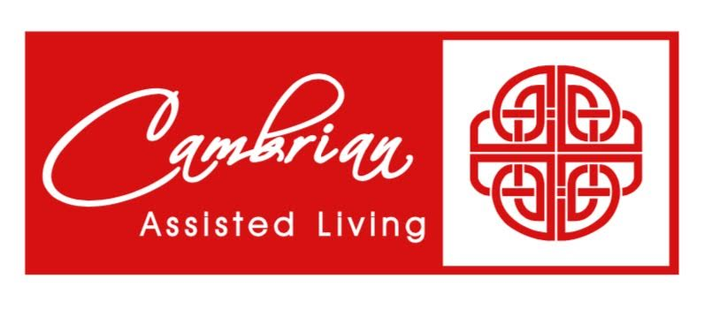
SUNDAY MONDAY TUESDAY WEDNESDAY THURSDAY FRIDAY SATURDAY

