SUNDAY | MONDAY | TUESDAY | WEDNESDAY | THURSDAY | FRIDAY | SATURDAY
1  9:30 Catholic  Communion  1:00 Activity Room  Games | 2 Labor Day  9:00 Basketball  9:30 Daily Chronicle  1:00 Bingo  4:00 Courtyard  Conversation | 3  9:00 Noodle Ball Sports  10:00 Catholic Mass  1:00 Card Games  4:00 Happy Hour | 4  10:00 The Price is Right  11:00 Kroger Trip  1:00 Wii Bowling  2:00 Mystery Out & About | 5  9:00 Basketball  9:30 Resident Council  1:00 Shuffleboard  4:00 Happy Hour | 6  9:00 Target Practice  9:30 Daily Chronicle  1:00 Friday Bingo  4:00 Craft Hour | 7  9:00 Bean Bag Toss &  Daily Chronicle  1:30 Worship Service  3:00 Trivia Hour
8  Grandparents Day  9:30 Catholic  Communion  1:00 Activity Room  Games | 9  9:00 Chair Pilates  9:30 Daily Chronicle  1:00 Bingo  4:00 Book Club | 10  9:00 Basketball  10:00 Daily Chronicle  1:00 Classic Car Show  Prep  4:00 Early Dinner  5:00 Classic Car Show | 11  10:15 Catholic Communion  10:30 911 Remembrance  1:00 Wii Bowling  4:00 Guitar & Song | 12  9:00 Music & Motion  9:30 Daily Chronicle  1:00 Bocce Ball  4:00 Happy Hour &  milkshakes | 13  9:00 Hall Hikers & Daily  Chronicle  10:00 Cooking Club  1:00 Drum Circle  4:00 Craft Hour | 14  9:00 Basketball & Daily  Chronicle  1:30 Worship Service  3:00 Trivia Hour
15  9:30 Catholic  Communion  1:00 Activity Room  Games | 16  9:00 Balance Class  9:30 Daily Chronicle  1:00 Bingo  4:00 Craft Hour | 17  9:00 Noodle Ball Sports  9:30 Daily Chronicle  10:00 Dancing through  Argentina  1:00 Card Games  4:00 Happy Hour | 18  10:15 Catholic Communion  11:00 Music & Worship w/Jo  11:00 Kroger Trip  1:00 Wii Bowling  3:00 Craft Hour | 19  9:00 Bean Bag Toss  9:30 Daily Chronicle  1:00 Shuffleboard  4:00 Happy Hour | 20  9:00 Target Practice  9:30 Daily Chronicle  10:00 Craft Hour  1:00 Erwin’s Orchards  Outing | 21  9:00 Music & Motion  9:30 Daily Chronicle  1:30 Worship Service  3:00 Dominos
22 Centenarians Day  9:30 Catholic  Communion  1:00 Activity Room  Games | 23 First day of Autumn  9:00 Balance Class  9:30 Daily Chronicle    1:00 Bingo  4:00 Craft Hour | 24  9:00 Basketball  9:30 Daily Chronicle  10:00 Cooking Club  12:00 Lunch w/LE  1:00 Master Watercolors  4:00 Happy Hour | 25  10:15 Catholic Communion  10:30 Daily Chronicle  1:00 Wii Bowling  3:00 Craft Hour | 26  9:00 Music & Motion  10:30 Cambrian Store  11:30 Cambrian Picnic  1:00 Shuffleboard  4:00 Happy Hour | 27  9:00 Hall Hikers & Daily  Chronicle  10:00 Craft Hour  1:00 Drums Alive  3:00 Pumpkinfest Float | 28  Pumpkin Fest Parade  9:00 Basketball & Daily  Chronicle  1:30 Worship Service  3:00 Dominos
29  9:30 Catholic  Communion  1:00 Activity Room  Games | 30  9:00 Chair Pilates  9:30 Daily Chronicle  1:00 Bingo  4:00 Cranium Crunch | Birthday’s this month  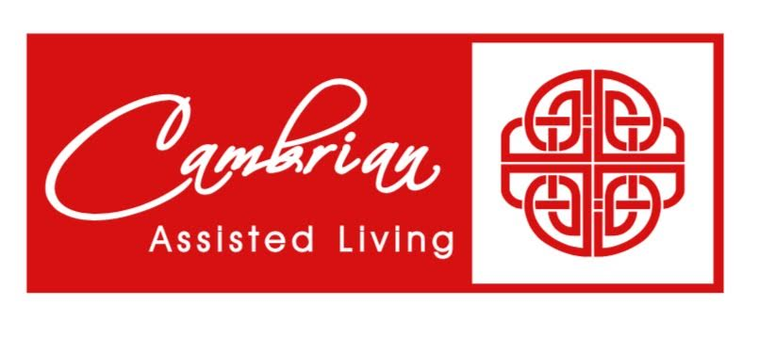    Les 9/9  Lucy 9/15  Betty 9.17    Jean 9/29

Cambrian Senior Living 52365 Ten Mile Rd South Lyon MI 48178

