SUNDAY | MONDAY | TUESDAY | WEDNESDAY | THURSDAY | FRIDAY | SATURDAY
 |  |  |  |  | 1  9:00 Target Practice  10:00 Best Costume  Voting  1:00 Travelogue to  Australia  3:30 Game Time | 2  9:00 Exercise  9:30 Daily Chronicle  1:30 Lutheran Worship  3:00 Dominos
3 FALL BACK  Daylight Savings Ends  9:30 Catholic  Communion  1:00 Dominos Club  4:05 Lions Football  3:00 Activity Room  Games | 4  9:00 Chair Pilates  9:30 Daily Chronicle  10:00 Coffee Klatch  1:00 Bingo  3:45 Prayer &  Worship | 5  9:00 Noodle Ball  Sports  10:00 Catholic Mass  1:00 Card Games  4:00 Happy Hour | 6  9:00 Brunch @  “The Breakfast Club”  1:00 Wii Bowling  3:30 Mahjong | 7  9:00 Basketball  9:30 Resident Council  1:00 Shuffleboard  2:00 Book Club  4:00 Happy Hour &  Meet & Greet Amanda Kramer | 8  9:00 Hall Hikers  9:30 Daily Chronicle  10:00 Cambrian Pen Pals  1:00 Drum Circle  3:30 Meet me @ MOMA – Art Presentation | 9  9:00 Exercise  9:30 Daily Chronicle  1:30 Lutheran Worship  3:00 Trivia Hour
10  9:30 Catholic  Communion  1:00 Dominos Club  1:10 Lions Football  3:00 Activity Room  Games | 11  9:00 Balance Class  9:30 Daily Chronicle  10:00 Remembering  Hedy Lamar  1:00 Bingo  4:00 Veterans Day  Observance | 12  9:00 Music & Motion  9:30 Daily Chronicle  10:00 Out & About  1:00 Dominos  2:00 Men’s Club  4:00 Happy Hour | 13  10:15 Catholic  Communion  11:00 Kroger Trip  1:00 Wii Bowling  4:00 Sweet Stories | 14  9:00 Cardio Crunch  9:30 Daily Chronicle &  Trivia  1:00 ARK Animal  Encounters  2:30 Book Club  4:00 Happy Hour | 15  9:00 Target Practice  9:30 Daily Chronicle  10:00 Armchair Travel  1:00 Craft Hour  3:00 Friday Bingo | 16  9:00 Exercise  9:30 Daily Chronicle  1:30 Lutheran Worship  3:00 Shuffleboard
17  9:30 Catholic  Communion  1:00 Dominos Club  1:00 Lions Football  3:00 Activity Room  Games | 18  9:00 Chair Pilates  9:30 Daily Chronicle  10:00 Happy Birthday  Mickey Mouse  1:00 Bingo  4:00 Giving Thanks | 19  9:00 Noodle Ball  Sports  10:00 Trivia  1:00 Card Sharks  4:00 Happy Hour &  Piano Recital | 20  10:15 Catholic  Communion  10:30 Zumba Gold  11:00 Worship & Song  11:00 Kroger Trip  1:00 Wii Bowling  3:30 Mahjong | 21  9:00 Basketball &  Daily Chronicle  11:00 Cambrian Store  1:00 Shuffleboard  2:00 Book Club  4:00 Happy Hour &  Short Story | 22  9:00 Hall Hikers  9:30 Daily Chronicle  10:00 Dominos  1:00 Drums Alive  3:00 Craft Hour | 23  9:00 Exercise  9:30 Daily Chronicle  1:30 Lutheran Worship  3:00 Cranium Crunch
24  9:30 Catholic  Communion  1:00 Dominos Club  1:00 Lions Football  3:00 Activity Room  Games | 25  9:00 Balance Class  9:30 Daily Chronicle  10:00 Beads of Courage  1:00 Bingo  3:45 Prayer & Worship | 26  9:00 Music & Motion  9:30 Daily Chronicle  1:00 Card Sharks  2:00 Men’s Club  4:00 Happy Hour | 27  10:15 Catholic  Communion  10:30 Zumba Gold  1:00 Wii Bowling  3:00 Community  Service Project | 28 Happy Thanksgiving  Parade  9 am– Noon  Thanksgiving Dinner  Noon  Lions Football 12:30 | 29  9:00 Target Practice  10 - noon  Decorate Tree @ Abbey  Park  1:00 Friday Bingo  5:00 Take-a-Way Trivia | 30  9:00 Exercise  9:30 Daily Chronicle  1:30 Lutheran Worship  3:00 Shuffleboard
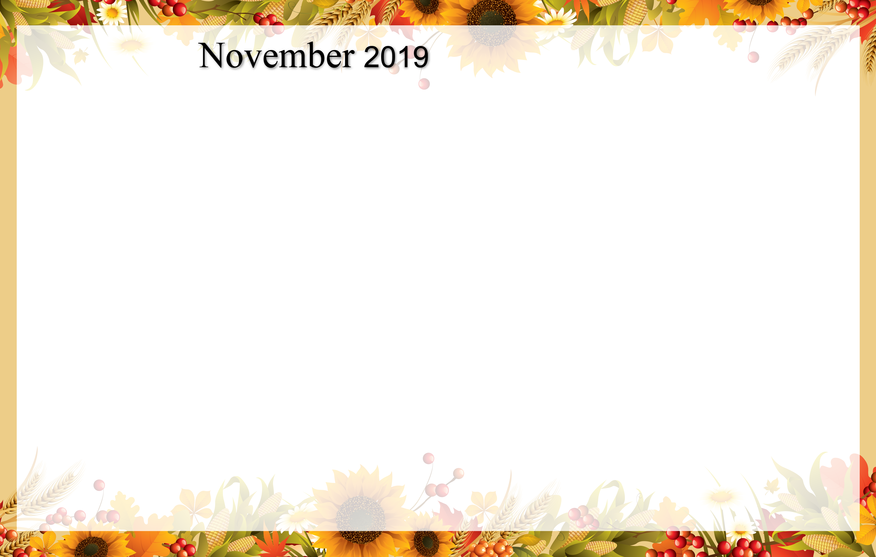
Cambrian Senior Living – 52365 10 Mile Road – South Lyon, MI 48178

