Friday
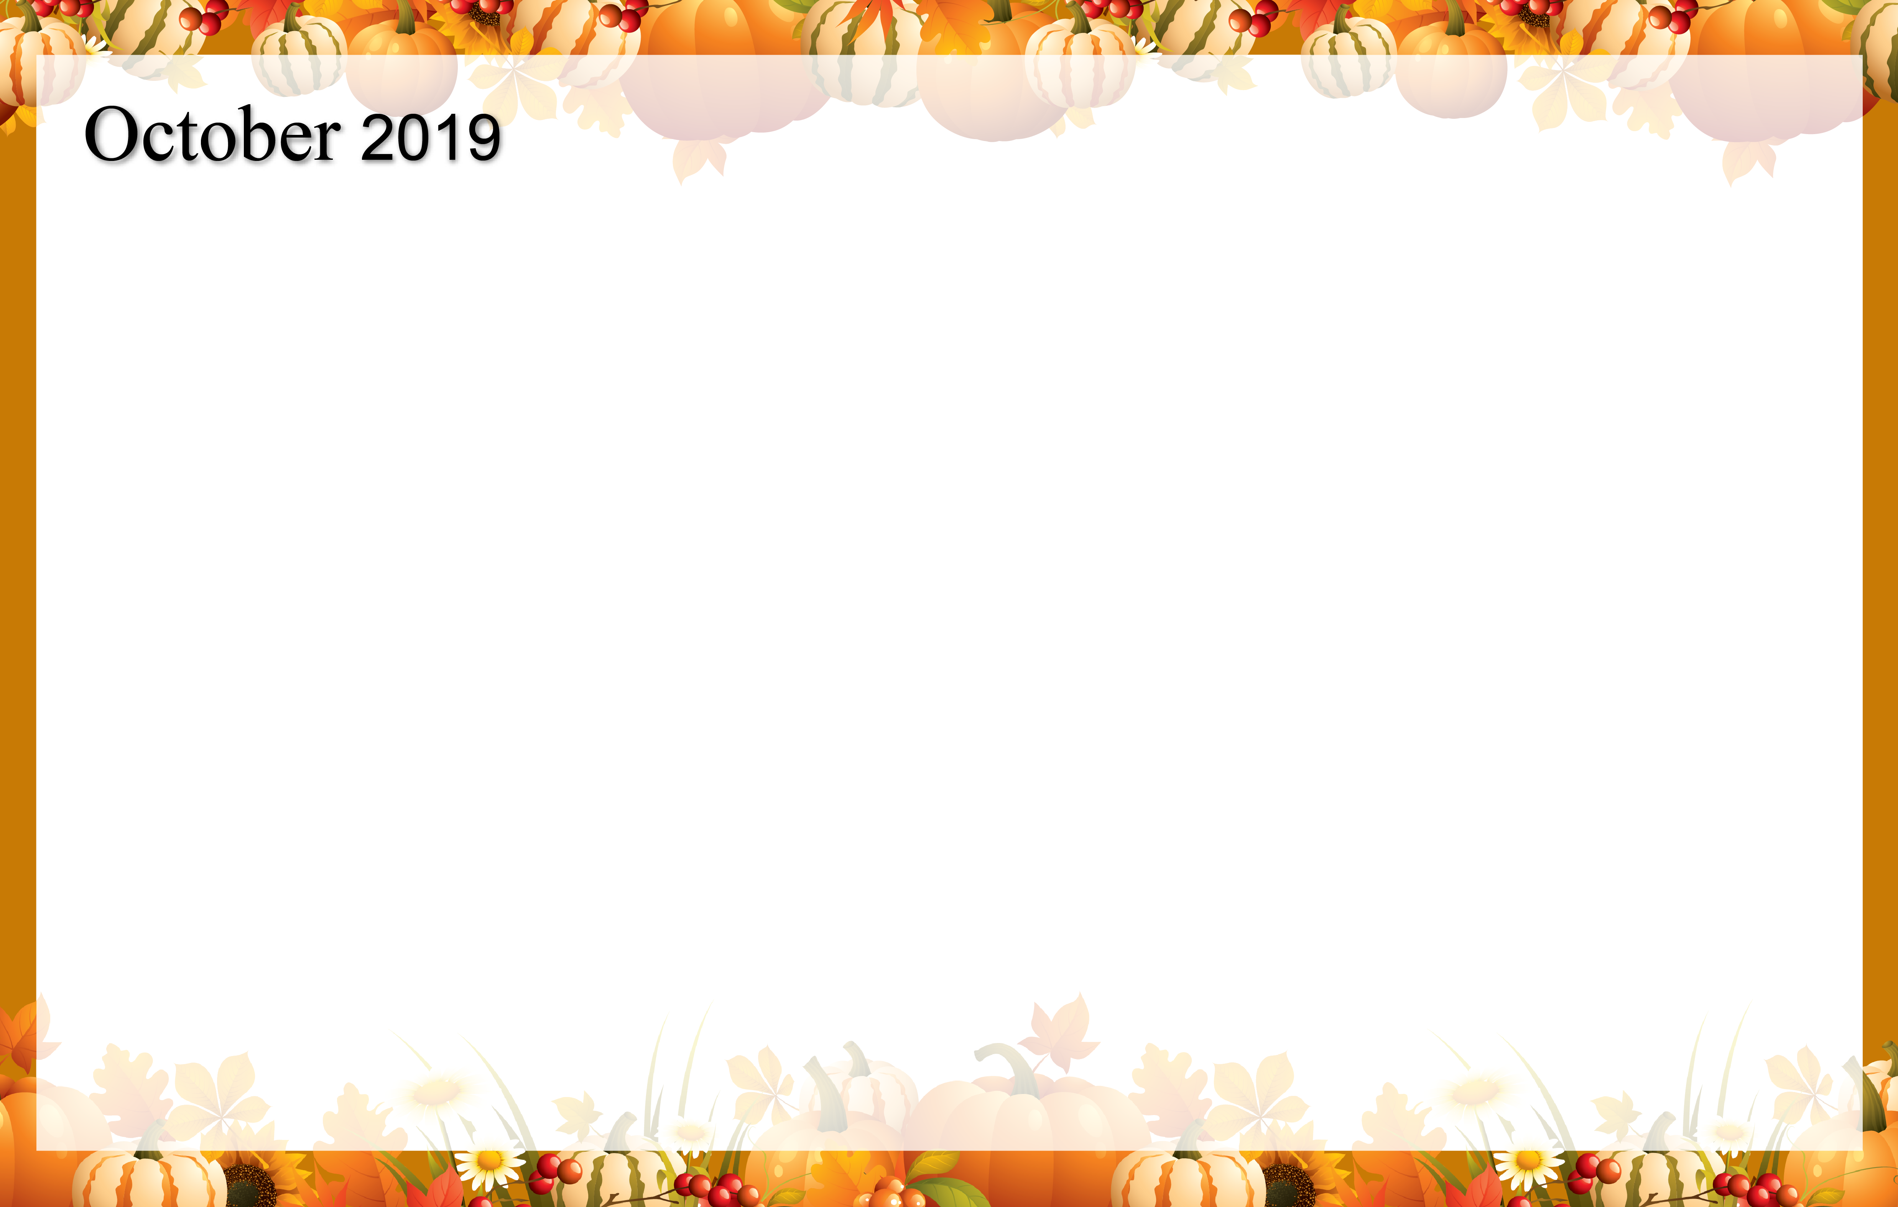 |  | 1  9:00 Noodle Hockey  10:00 Catholic Mass  1:00 Dominos  4:00 Happy Hour | 2  10:00 Cardio Crunch  11:00 Kroger Trip  1:00 Wii Bowling  4:00 Baking Club | 3  Wear Pink Today  9:00 Basketball  10:00 Resident Council  1:00 Shuffleboard  2:00 Book Club  4:00 Happy Hour |  | 4  Wear Purple Today  9:00 Target Practice  9:30 Daily Chronicle &  Trivia  1:00 Friday Bingo | 5  Wear Your Team Colors  MERCY IN ACTION DAY  St Joseph Church  BINGO  9:30 – 11:30  1:30 Lutheran Worship
6  9:30 Catholic Communion  1:00 Activity Room  Games | 7  9:00 Meet & Greet with  Tricia  9:30 Daily Chronicle  1:00 Bingo  2:00 Travel to Monaco  4:00 Prayer & Worship | 8  9:00 Bean Bag Toss  9:30 Daily Chronicle  10:00 Trivia  1:00 Card Sharks  2:00 Fall Crafts  4:00 Happy Hour | 9  9:00 Exercise  10:15 Catholic Communion  11:00 Kroger Trip  1:00 Wii Bowling  2:00 Mystery Out & About | 10  9:00 Basketball  10:30 News & Trivia  1:00 Shuffleboard  2:00 Book Club  4:00 Happy Hour |  | 11  9:00 Hall Hikers  11:00 Daily Chronicle &  Trivia  1:00 Drum Circle  4:00 Cranium Crunch | 12  9:00 Music & Motion  9:30 Daily Chronicle  1:30 Lutheran Worship  3:00 The Price is Right
13  9:30 Catholic Communion  1:00 Activity Room  Games | 14  9:00 Balance Class  9:30 Trivia  1:00 Bingo  3:30 Art Connection | 15  9:00 Noodle Ball sports  11:00 Reminisce  1:00 Putt-Putt Golf  2:00 Men’s Club  4:00 Happy Hour | 16  10:15 Catholic Communion  11:00 Worship and Song  with Jo  11:00 Kroger Trip  1:00 Wii Bowling  3:30 Learn Magog  w/Christine | 17  9:00 Basketball  9:30 Daily Chronicle  1:00 Shuffleboard  2:00 Penny Auction  4:00 Happy Hour &  Entertainment |  | 18  9:00 Target Practice  9:30 Daily Chronicle  10:00 Community Outreach  1:00 Garden Clean up  4:00 Friday Bingo | 19  9:00 Music & Motion  9:30 Daily Chronicle  1:30 Lutheran Worship  3:00 Trivia Hour
20  9:30 Catholic Communion  1:00 Activity Room  Games | 21  9:00 Chair Pilates  9:30 Daily Chronicle  1:00 Bingo  4:00 Prayer and Worship | 22  9:00 Noodle Ball sports  9:30 Daily Chronicle  11:00 Aubree’s Lunch & Dollar Store Outing  2:00 Celebration of Lives  4:00 Happy Hour | 23  10:15 Catholic Communion  11:00 Kroger Trip  1:00 Wii Bowling  3:00 Bake with Me | 24  9:00 Basketball  10:30 News & Trivia  1:00 Shuffleboard  2:00 Cambrian Store  4:00 Happy Hour |  | 25  9:00 Hall Hikers  11:00 Daily Chronicle &  Trivia  1:00 Drums Alive  4:00 Book Club | 26  9:00 Music & Motion  9:30 Daily Chronicle  1:00 Halloween Party  2:00 Lutheran Worship
27  9:30 Catholic Communion  1:00 Activity Room  Games | 28  9:00 Balance Class  10:00 Trivia  1:00 Bingo  3:30 Art Connection | 29  9:00 Noodle Ball sports  11:30 Lunch with LE  1:00 Dominos  2:00 Men’s Club  4:00 Happy Hour | 30  10:15 Catholic Communion  11:00 Kroger Trip  1:00 Wii Bowling  4:00 Book Club | 31  9:00 Cardio Crunch  9:30 Daily Chronicle  1:00 Shuffleboard  3:00 Costume Party  4:00 Happy Hour | Happy Birthday Mo 10/2 Dorothy 10/2 Ron 107Barb 10/27  
Cambrian Senior Living = 52365 Ten Mile Road - .South Lyon MI 48178

