|  |  |  |  |  |  |  |
| --- | --- | --- | --- | --- | --- | --- |
| **1**  **9:30** Communion  **1:00** Dominos Club  **3:00** Activity Room  Games | **2**  **9:00** Bean Bag Toss  **9:30** Daily Chronicle  **10:00** Hanging of the  greens  **1:00** Bingo  **3:30** Mahjong | **3**  **9:00** Noodle Ball  Sports  **10:00** Catholic Mass  **1:00** Card Games  **4:00** Happy Hour | **4**  **10:15** Communion  **10:30** Zumba Gold  11:00 Carols w/Jo  **11:00** Kroger Trip  **1:00** Wii Bowling  **4:00** Rummy King | **5**  **9:00** Basketball  **9:30** Resident Council  **1:00** Shuffleboard  **2:00** Book Club  **4:00** Happy Hour | **6**  **9:00** Target Practice  **9:30** Daily Chronicle  **10:00** Book Club  **1:00** Drum Circle  **3:00** Friday Bingo | **7**  **9:00** Exercise & Daily Chronicle  **1:30** Worship Service  **3:30** Violin Concert |
| **8**  **9:30** Communion  **1:00** Dominos Club  **1:00** Lions Football  **3:00** Activity Room  Games | **9**  **9:00** Balance Class  **10:00** Daily Chronicle &  Trivia  **11:00** Carols w/Jo  **1:00** Bingo  **4:00**  Christmas Cards | **10 Grinch Day**  **9:00** Noodle Ball Sports  **9:30** Daily Chronicle  **10:30** Christmas Carolers  **1:00** Card Games  **3:00** Grinch Snack  **4:00** Happy Hour | **11**  **10:15** Communion  **10:30** Zumba Gold  **11:00** Target Trip  **1:00** Wii Bowling  **2:30** Craft Hour | **12**  **9:00** Cardio Crunch  **9:30** Daily Chronicle  **11:00** Trivia  **4:00** Early Dinner  ***Resident Christmas Party***  **7 – 8:30** | **13**  **9:00** Hall Hikers  **9:30** Daily Chronicle  **10:00** Book Club  **1:00** Craft Hour  **3:00** SLEHS Band &  Choir Concert | **14**  **9:00** Exercise & Daily  Chronicle  1:30 Worship Service  3:00 Christmas Carolers |
| **15**  **9:30** Communion  **1:00** Dominos Club  **4:00** Christmas  Carols  **5:30** Adopt a Grandparent – songs  & gifts | **16**  **9:00** Bean Bag Toss  **9:30** Daily Chronicle  **10:00** Meet me @ MOMA  **1:00** Bingo  **3:30** Christmas Sing-a  -Long | **17**  **9:00** Noodle Ball Sports  **9:30** Daily Chronicle  **10:00**  **“A beautiful day in the Neighborhood” Movie and lunch outing**  **4:00** Happy Hour | **18**  **10:15** Communion  **10:30** Zumba Gold  **11:00** Kroger Trip  **11:00** Carols w/Jo  **1:00** Wii Bowling  **2:30** Craft Hour | **19**  **9:00** Cardio Crunch  **9:30** Daily Chronicle  **10:00** Craft & Carols  **1:00** Cambrian Store  **4:00** Happy Hour | **20 Ugly Sweater Day**  **9:00** Target Practice  **9:30** Daily Chronicle  **10:00** Book Club  **3:30** Mahjong | **21 First day of Winter**  **9:00** Exercise & Daily  Chronicle  **11:00** Piano  Performance  **1:30** Worship Service  **3:00** Shuffleboard |
| **22**  **9:30** Communion  **1:00** Dominos Club  **1:00** Lions Football  **3:00** Activity Room  Games | **23**  **9:00** Chair Pilates  **9:30** Daily Chronicle  **10:00**  Trivia  **1:00** Bingo  **4:00** Light tour & Pizza | **24 Christmas Eve**  **10:00** Cardio Crunch  **10:30** Daily Chronicle  **1:00** Dominos Club  **2:00** Social Hour  Activity Room | **25** | **26**  **9:00** Basketball  **9:30** Daily Chronicle  **1:00** Drums Alive  **2:00** Shuffleboard  **4:00** Happy Hour | **27**  **9:00** Hall Hikers  **10:00** Book Club  **1:00** Celebrating Winter  Solstice  **3:00** Movie & Snacks | **28**  **9:00** Exercise  **9:30** Daily Chronicle  **1:30** Lutheran Worship  **4:00** Bingo |
| **29**  **9:30** Communion  **1:00** Dominos Club  **1:00** Lions Football  **3:00** Activity Room  Games | **30**  **9:00** Noodle Sports  **9:30** Daily Chronicle  **1:00** Bingo  **3:00** Prayer & Devotion | **31 New Years Eve**  **9:00** Bean Bag Toss  **9:30** Daily Chronicle  **Noon** New Years Toast  **1:00** Rummy King  **2:00** Reflection on 2019 | *Please see our daily sheets for addition information or change in time or events.*  *Activities, Outings and times subject to change due to weather conditions* |  | | |

SUNDAY MONDAY TUESDAY WEDNESDAY THURSDAY FRIDAY SATURDAY

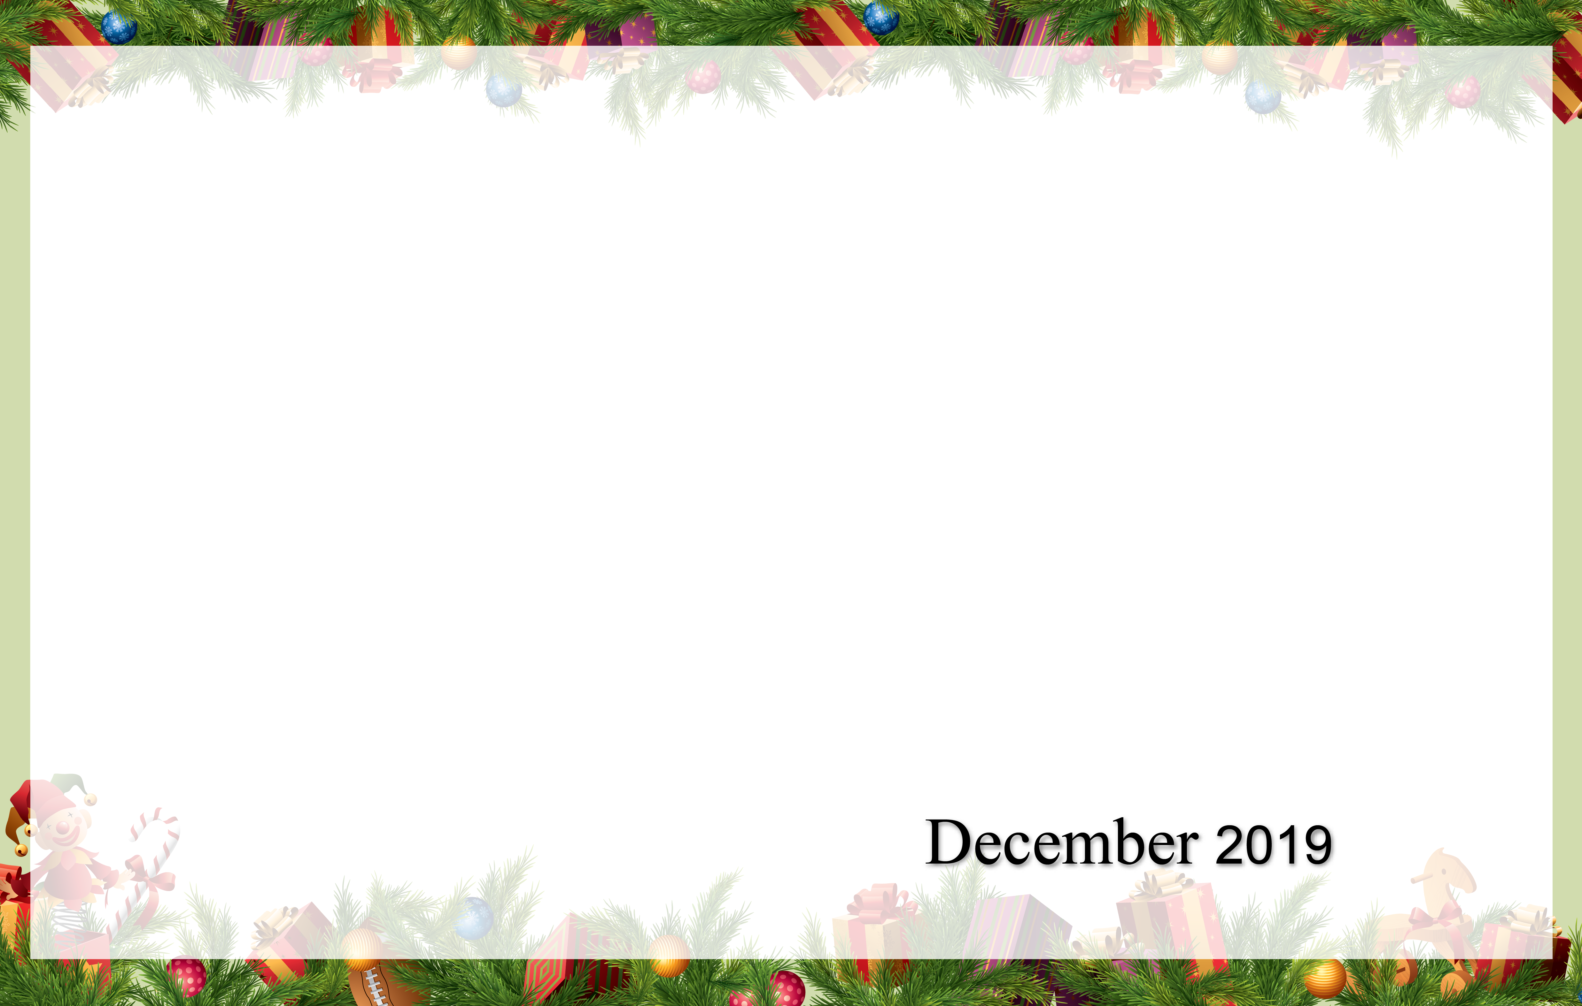

Cambrian Senior Living *52365 10 Mile Rd. * South Lyon, MI 48178 * [www.cambrianseniorliving.com](http://www.cambrianseniorliving.com) * Like us on Facebook