: |  |  | 1 Beauty Shop  10:15 Catholic Communion  1:00 Wii Bowling  3:00 Book Club | 2 Beauty Shop  9:30 Basketball  10:00 Resident Council  1:00 Shuffleboard  4:00 Happy Hour | 3  9:30 Target Practice  10:00 Daily Chronicle  1:15 Drum Circle  3:00 Travel to Texas & Passport Stamp | 4  10:00 Exercise & Daily  Chronicle  1:30 Worship Service  2:15 Trivia & Treats
5  9:30 Catholic  Communion  1:00 Dominos Club  3:00 Activity Room  Games | 6  9:30 Bean Bag Toss  10:00 Daily Chronicle &  Trivia  1:00 Bingo  3:30 Mahjong | 7 Beauty Shop  9:30 Daily Chronicle  10:00 Catholic Mass  1:00 Card Games  4:00 Happy Hour | 8 Beauty Shop  10:30 Zumba Gold  11:00 Kroger Trip  1:00 Wii Bowling  2:00 Book Club  4:00 Entertainment | 9 Beauty Shop  9:30 Cardio Crunch  11:00 Trivia  1:00 Out & About  4:00 Happy Hour | 10  9:30 Hall Hikers  10:00 Daily Chronicle  1:00 Craft Hour  3:00 Friday Bingo | 11  10:00 Exercise & Daily  Chronicle  1:30 Worship Service  2:15 Game Time
12  9:30 Catholic  Communion  1:00 Dominos Club  3:00 Activity Room  Games | 13  9:30 Balance Class  10:00 Daily Chronicle  1:00 Bingo  3:30 Devotions & Prayer | 14 Beauty Shop  9:30 Noodle Ball Sports  10:00 Daily Chronicle  11:00 Trivia  1:00 Card Games    4:00 Happy Hour | 15 Beauty Shop  10:15 Catholic Communion  10:30 Zumba Gold  11:00 Worship w/ Jo (MC)  11:00 Kroger Trip  1:00 Wii Bowling  2:00 Book Club | 16 Beauty Shop  Fig Newton Day  9:30 Basketball  10:00 Trivia  1:00 Shuffleboard  4:00 Happy Hour | 17  9:30 Target Practice  10:00 Daily Chronicle  1:00 Craft & Cocoa  4:00 Art Connection | 18  10:00 Exercise & Daily  Chronicle  1:30 Lutheran Worship  2:15 Trivia & Treats
19  9:30 Catholic  Communion  1:00 Dominos Club  3:00 Activity Room  Games | 20  9:30 Bean Bag Toss  10:00 Daily Chronicle &  Trivia  1:00 Bingo  3:30 Mahjong | 21  Give me a Hug Day  9:30 Noodle Ball Sports  10:00 Daily Chronicle  11:00 Trivia  1:00 Card Games  4:00 Happy Hour | 22  10:15 Catholic Communion  11 – 2  Pinz Bowling & Pizza lunch outing  4:00 Book Club | 23 Beauty Shop  9:30 Cardio Crunch  10:00 Daily Chronicle  10:30 Cambrian Store  1:00 Shuffleboard  4:00 Happy Hour | 24  9:30 Hall Hikers  10:00 Daily Chronicle  1:00 Drums Alive  4:00 Friday Bingo | 25  9:30 Tai Ji  1:30 Lutheran Worship  2:15 Game Time
26  9:30 Catholic  Communion  1:00 Dominos Club  3:00 Activity Room  Games | 27  Marshmallow Day  9:30 Balance Class  10:00 Daily Chronicle  1:00 Bingo  2:30 SMORES  3:30 Devotions & Prayer | 28  9:30 Noodle Ball Sports  10:00 Daily Chronicle  11:00 Tea & Trivia  1:00 Card Games  4:00 Happy Hour | 29  10:15 Catholic Communion  10:30 Zumba Gold  11:00 Kroger Trip  1:00 Wii Bowling  2:00 Book Club | 30  9:30 Basketball & Daily  Chronicle  10:00 Trivia  1:00 Shuffleboard  4:00 Happy Hour | 31  9:30 Target Practice  10:00 Daily Chronicle  1:00 Craft Hour  4:00 Rummy King | Times, Activities & Outings subject to change    Please check the Daily Sheets for up to date schedule
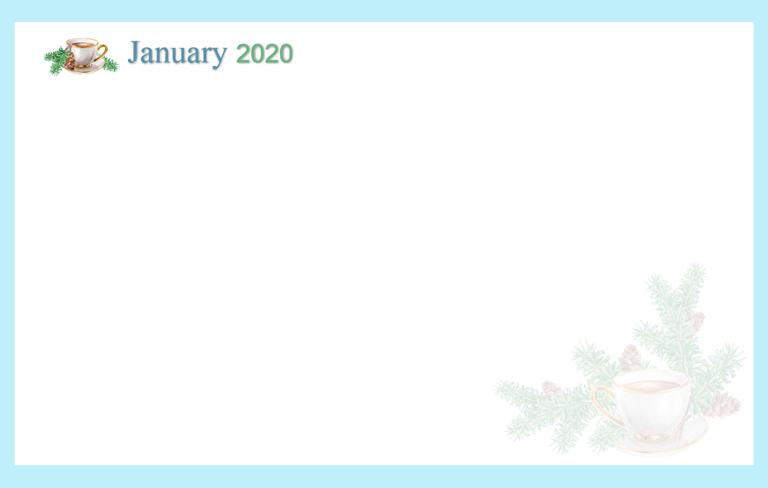
SUNDAY MONDAY TUESDAY WEDNESDAY THURSDAY FRIDAY SATURDAY
Cambrian Senior Living *52365 10 Mile Rd. * South Lyon, MI 48178 * www.cambrianseniorliving.com * Like us on Facebook

