|  |  |  |  |  |  |  |
| --- | --- | --- | --- | --- | --- | --- |
|  | | | | **1**  **10:00** Basketball  **1:00** Pen Pals  **4:00** Happy Hour | **2**  **10:00** Target Practice  **1:00** World Smile Day  **4:00** October Trivia | **3**  **10:00** Bean Bag Toss  1:00 Game Hour |
| **4** | **5**  **10:00** Noodle Ball Sports  **1:00** Bingo  **4:00** Devotion & Music | **6**  **10:00** Bean Bag Toss  **1:00** ACE Bingo  **4:00** Happy Hour | **7**  **10:00** Music & Motion  **1:00** Wii Bowling  **4:00**  Piano Concert –  Yuta Sugano | **8**  **10:00** Basketball  **1:00** Pen Pals  **4:00** Happy Hour | **9**  **10:00** Hall Hikers  **1:00** Cambrian Cooking  Club**:** Apple Butter  **4:00** Trivia Hour | **10**  **10:00** Basketball  **1:00** Game Hour |
| **11**  **October Birthdays**  ***Dorothy* 10/2**  ***Mo*  10/2**  ***Ron*  10/7**  ***Shirley*  10/23** | **12**  **10:00** Cardio Crunch  **1:00** Bingo  **4:00** Travelogue –  All aboard the Canadian  Express | **13**  **10:00** Bean Bag Toss  **1:00** Happy Birthday  White house Trivia  **4:00** Happy Hour | **14**  **10:00** Music & Motion  **1:00** Wii Bowling  **4:00** Who, What, When | **15**  **10:00** Basketball  **1:00** Pen Pals  **4:00** Happy Hour | **16**  **10:00** Target Practice  **1:00** Painted Pumpkins  **4:00** Trivia Hour  ” | **17**  **10:00** Cardio Crunch  **1:00** Game Hour |
| **18**  Beauty Salon/Barber  Manicures by Appointment | **19**  **10:00**  Noodle Ball Sports  **1:00** Bingo  **4:00** Devotion & Music | **20**  **10:00** Bean Bag Toss  **1:00** Cambrian Cooking  Club: Pumpkin  Cheesecake Cups  **4:00** Happy Hour | **21**  **10:00** Music & Motion  **1:00** Wii Bowling  **4:00**  Magazine  Scavenger Hunt | **22**  **10:00** Basketball  **1:00** Pen Pals  **2:00** Paper Lantern  Pumpkins  **4:00** Happy Hour | **23**  **10:00** Hall Hikers  **1:00** Friday Bingo  **4:00** Trivia Hour | **24**  **10:00** Music & Motion  **1:00** Game Hour |
| **25** | **26**  **10:00** Cardio Crunch  **1:00** Bingo  **2:00** Resident Council  **4:00** Wheel of Fortune – Happy Birthday Pat Sajak | **27**  **10:00** Bean Bag Toss  **1:00** ACE Bingo  **4:00** Happy Hour | **28**  **10:00** Music & Motion  **1:00** Wii Bowling  **4:00** Short Story: A walk  through the woods | **29**  **10:00** Basketball  **1:00** Cambrian Store  **2:00** Pen Pals  **4:00** Happy Hour | **30**  **10:00** Target Practice  **1:00** Halloween Party  **4:00** Trivia Hour | **31 Halloween**  **10:00** Basketball  **1:00** Game Hour |

SUNDAY MONDAY TUESDAY WEDNESDAY THURSDAY FRIDAY SATURDAY

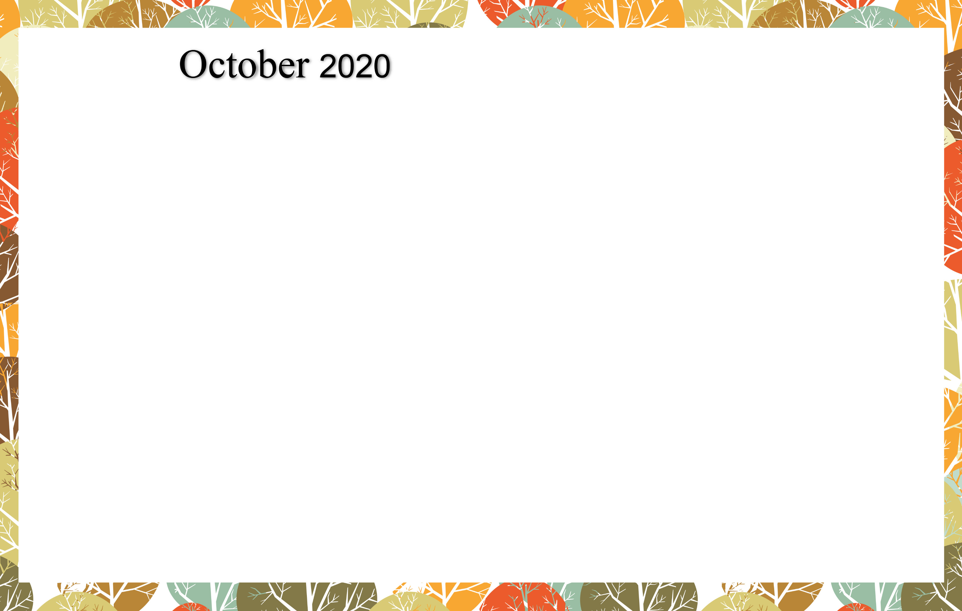

Cambrian Senior Living *52365 10 Mile Rd. * South Lyon, MI 48178 * [www.cambrianseniorliving.com](http://www.cambrianseniorliving.com) * Like us on Facebook