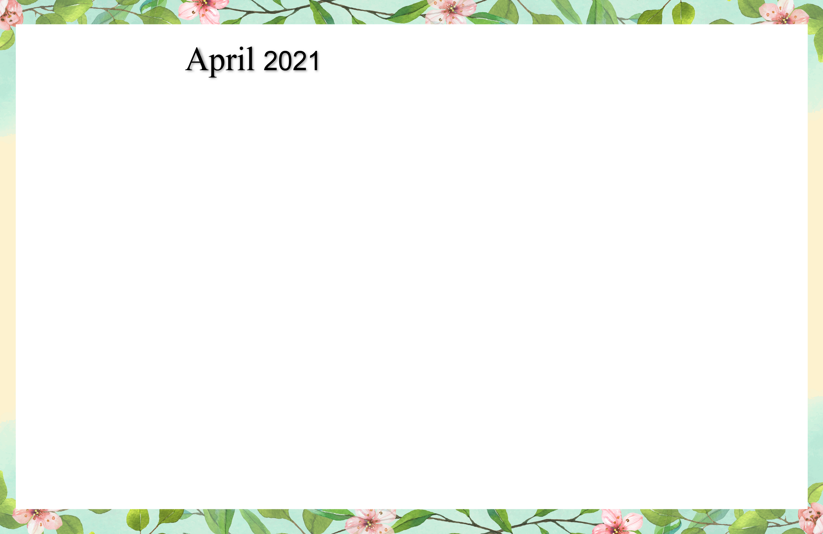

SUNDAY MONDAY TUESDAY WEDNESDAY THURSDAY FRIDAY SATURDAY

Cambrian Senior Living *52365 Ten Mile Road South Lyon, MI 48178 * [www.cambrianseniorliving.com](http://www.cambrianseniorliving.com) * Like us on Facebook

|  |  |  |  |  |  |  |  |  |  |
| --- | --- | --- | --- | --- | --- | --- | --- | --- | --- |
| assitedlivinglogo | | | | **1**    **9:30** Basketball  **1:00** Tigers Baseball  Opening Day!  **2:00** Catholic Rosary  **4:00**  Happy Hour | | | **2**  **9:30** Target Practice  **1:00** Trivia  **2:00** Catholic Rosary  **4:00** Good Friday non-denominational service | 3  9:30 Exercise &  Daily Chronicle  1:00 Game Hour  **2:00** Catholic Rosary | |
| **4**  ***Free Spiritual Easter Cliparts, Download Free Clip Art, Free Clip Art on  Clipart Library***  **2:00** Catholic Rosary | **5**  **9:30** Noodle Ball Sports  **1:00** Bingo  **2:00** Catholic Rosary | **6  *Beauty Shop***    **9:30** Bean Bag Toss  **1:00** Card Games  **2:00** Catholic Rosary  **4:00** Happy Hour –  Caramel day | **7  *Beauty Shop***  **9:30** Music & Motion  **1:00** Wii Bowling  **2:00** Catholic Rosary | **8**  **9:30** Basketball  **1:00**  Shuffleboard  **2:00** Catholic Rosary  **4:00**  Happy Hour | | **9**    **9:30** Target Practice  **1:00** Trivia  **2:00** Catholic Rosary | | **10**  9:30 Exercise &  Daily Chronicle  1:00 Game Hour  **2:00** Catholic Rosary | |
| **11**  **9:30** Devotion & Music  **2:00** Catholic Rosary | **12**  **9:30** Cardio Crunch  **1:00** Bingo  **2:00** Catholic Rosary | **13** **Beauty Shop**  **9:30** Cardio Drumming  **1:00** Card Games  **2:00** Catholic Rosary  **4:00** Happy Hour | **14  *Beauty Shop***  **9:30** Music & Motion  **1:00** Wii Bowling  **2:00** Catholic Rosary | **15**  **9:30** Basketball  **1:00** Wheel of Fortune  **2:00** Catholic Rosary  **4:00**  Happy Hour | | **16**  **9:30** Target Practice  **1:00** Friday Bingo  **2:00** Catholic Rosary | | 17  9:30 Exercise &  Daily Chronicle  1:00 Game Hour  **2:00** Catholic Rosary | |
| **18**  **9:30** Devotion & Songs  **2:00** Catholic Rosary | **19**  **9:30** Noodle Ball Sports  **1:00** Bingo & Resident  Council  **2:00** Catholic Rosary | **20  *Beauty Shop***  **9:30** Cardio Drumming  **1:00** Card Games  **2:00** Catholic Rosary  **4:00** Happy Hour | **21**  ***Beauty Shop***  **9:30** Music & Motion  **1:00** Wii Bowling  **2:00** Catholic Rosary | **22**  **9:30** Basketball  **1:00** Wheel of Fortune  **2:00** Catholic Rosary  **4:00**  Happy Hour | | **23**  **9:30** Target Practice  **1:00** Trivia  **2:00** Catholic Rosary | | **24**  9:30 Exercise &  Daily Chronicle  1:00 Game Hour  **2:00** Catholic Rosary | |
| **25**  **9:30** Devotion & Songs  **1:00** Cambrian Choir  **2:00** Catholic Rosary | **26**  **9:30** Cardio Crunch  **1:00** Bingo  **2:00** Catholic Rosary | **27 Beauty Shop**  **9:30** Bean Bag Toss  **1:00** Card Games  **2:00** Catholic Rosary  **4:00** Happy Hour | **28 Beauty Shop**  **9:30** Music & Motion  **1:00** Wii Bowling  **2:00** Catholic Rosary | **29**  **9:30** Basketball  **1:00** Cambrian Store  **2:00** Catholic Rosary  **4:00** Happy Hour | **30**  **9:30** Target Practice  **1:00** Friday Bingo  **2:00** Catholic Rosary | | | |  |