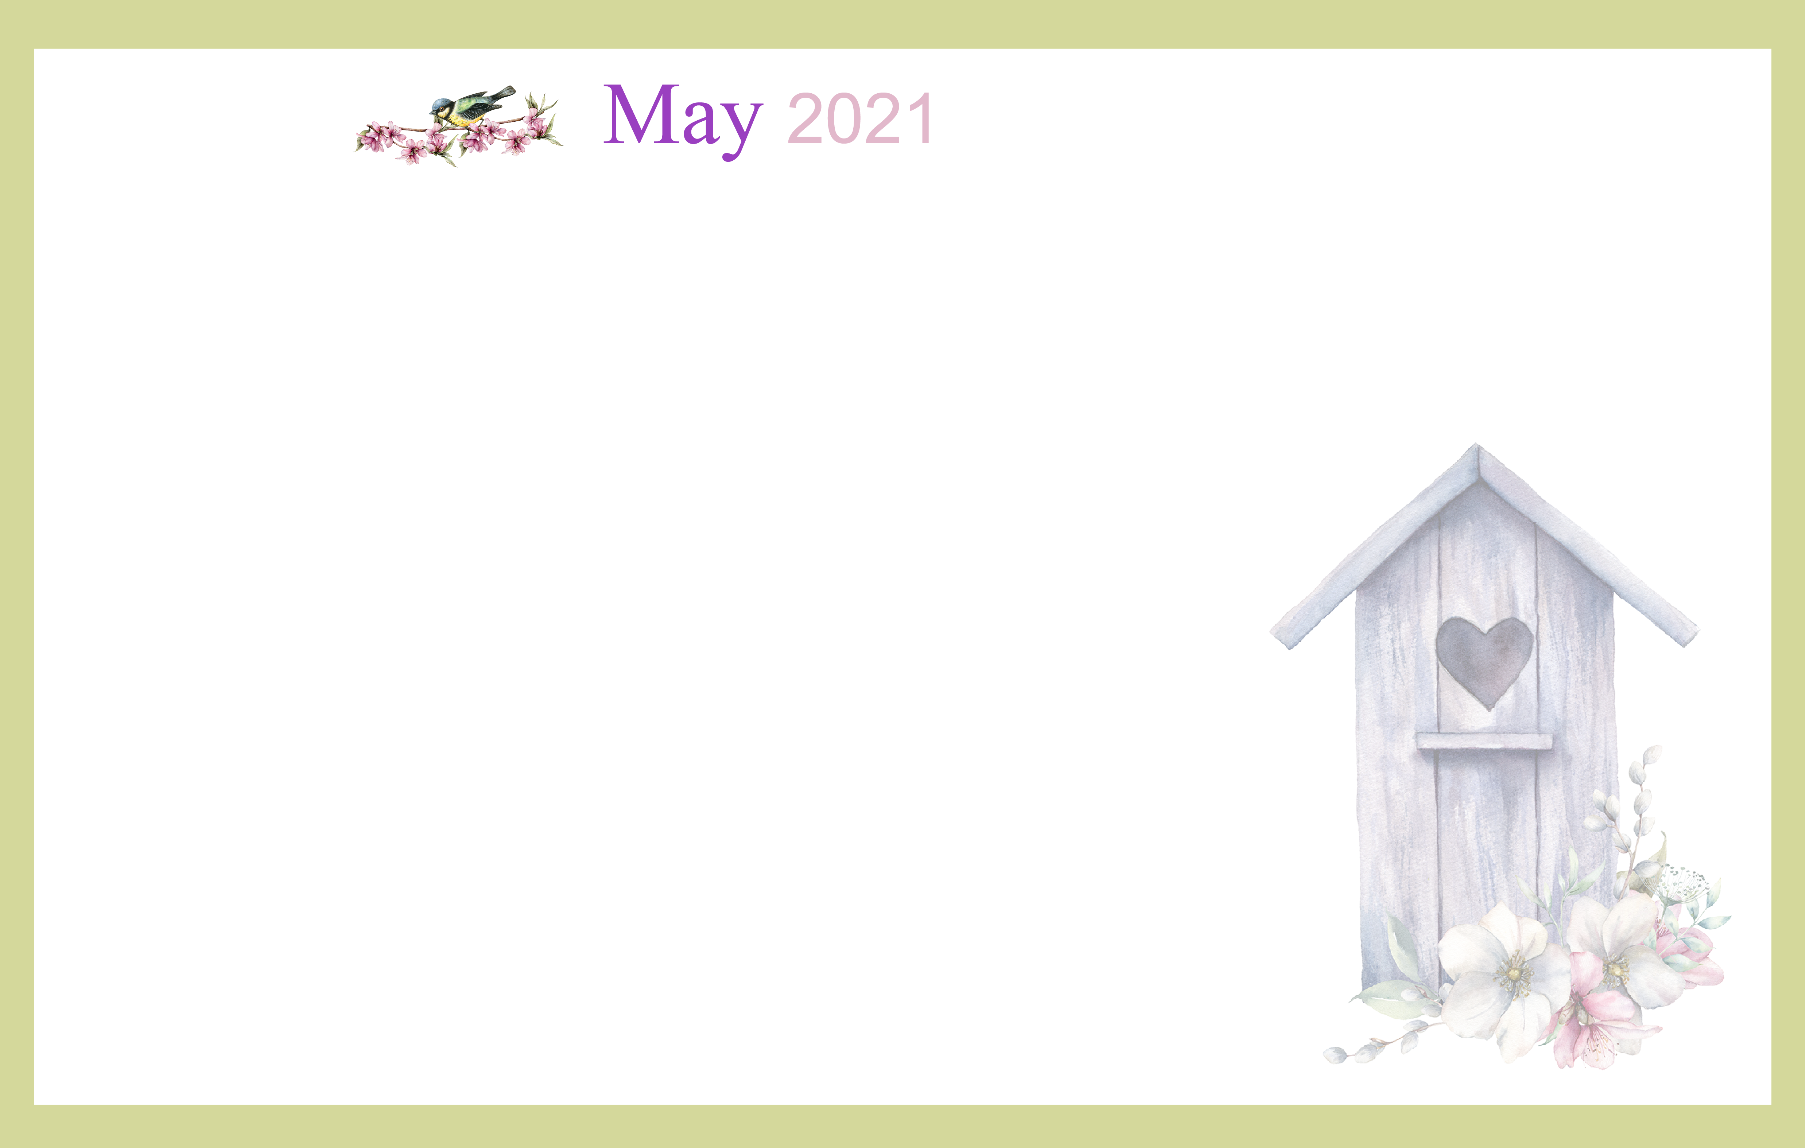
1
9:30 Exercise &
Daily Chronicle
1:00 Derby Horse
Racing Game
2:00 Catholic Rosary
6:50 Kentucky Derby
Race on NBC
2  9:30 Devotion, music &  communion  2:00 Catholic Rosary | 3  9:30 Noodle Ball Sports &  Daily Chronicle  1:00 Bingo  2:00 Catholic Rosary | 4 Beauty Shop  9:30 Bean Bag Toss  1:00 Card Games  2:00 Catholic Rosary  4:00 Happy Hour –  Cinco de Mayo Style | 5 Beauty Shop  9:30 Music & Motion &  Daily Chronicle  1:00 Wii Bowling  2:00 Catholic Rosary | 6  9:30 Basketball  Noon  Mother’s Day Resident Luncheon  2:00 Catholic Rosary  4:00 Happy Hour | 7  9:30 Target Practice &  Daily Chronicle  1:00 Trivia  2:00 Catholic Rosary | 8  9:30 Exercise &  Daily Chronicle  11:00 Communion  1:00 Game Hour  2:00 Catholic Rosary
9  Happy Mother’s Day!  9:30 Devotion & Music  2:00 Catholic Rosary  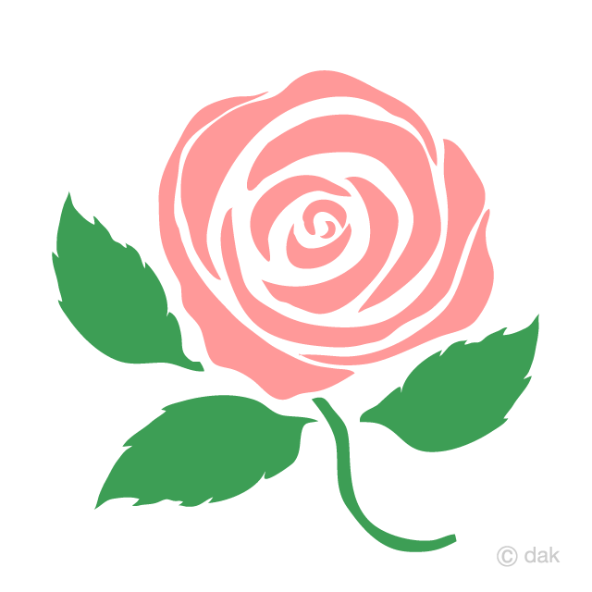 | 10  9:30 Cardio Crunch &  Daily Chronicle  1:00 Bingo  2:00 Catholic Rosary | 11 Beauty Shop  9:30 Cardio Drumming  1:00 America Says  2:00 Catholic Rosary  4:00 Happy Hour | 12 Beauty Shop  9:30 Music & Motion &  Daily Chronicle  1:00 Wii Bowling  2:00 Catholic Rosary | 13  9:30 Basketball  1:00 Shuffleboard  2:00 Catholic Rosary  4:00 Happy Hour | 14  9:30 Target Practice &  Daily Chronicle  1:00 Trivia  2:00 Catholic Rosary | 15  9:30 Exercise &  Daily Chronicle  1:00 Game Hour  2:00 Catholic Rosary
16  9:30 Devotion & Music  2:00 Catholic Rosary | 17  9:30 Noodle Ball Sports &  Daily Chronicle  1:00 Bingo & Resident  Council  2:00 Catholic Rosary | 18 Beauty Shop  9:30 Chair Exercise  1:00 Card Games  2:00 Catholic Rosary  4:00 Happy Hour | 19 Beauty Shop  9:30 Music & Motion &  Daily Chronicle  1:00 Wii Bowling  2:00 Catholic Rosary | 20  9:30 Basketball  1:00 Wheel of Fortune  2:00 Catholic Rosary  4:00 Happy Hour | 21  9:30 Target Practice &  Daily Chronicle  1:00 Friday Bingo  2:00 Catholic Rosary | 22  99:30 Exercise &  Daily Chronicle  11:00 Communion  1:00 Game Hour  2:00 Catholic Rosary
23  9:30 Devotion & Music  2:00 Catholic Rosary  30  9:30 Devotion,  Music &  Communion  2:00 Catholic Rosary | 24  9:30 Cardio Crunch  1:00 Bingo  2:00 Catholic Rosary 31  9:30 Cardio Crunch  1:00 Bingo  2:00 Catholic Rosary  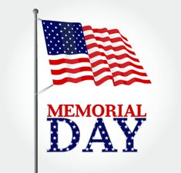 | 25 Beauty Shop  9:30 Bean Bag Toss  1:00 Card Games  2:00 Catholic Rosary  4:00 Happy Hour | 26 Beauty Shop  9:30 Music & Motion &  Daily Chronicle  1:00 Wii Bowling  2:00 Catholic Rosary | 27  9:30 Basketball  1:00 Shuffleboard  2:00 Catholic Rosary  4:00 Happy Hour | 28  9:30 Target Practice &  Daily Chronicle  1:00 America Says  2:00 Catholic Rosary |  | 29  9:30 Exercise &  Daily Chronicle  1:00 Game Hour  2:00 Catholic Rosary
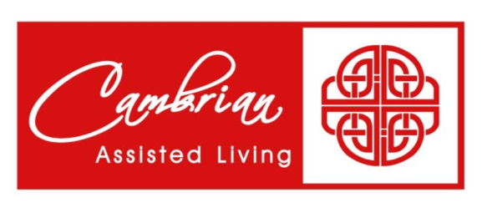
SUNDAY MONDAY TUESDAY WEDNESDAY THURSDAY FRIDAY SATURDAY

