Please see our daily sheets for addition information or change in time or events.    Activities and times subject to change  “Like” us on Facebook! | 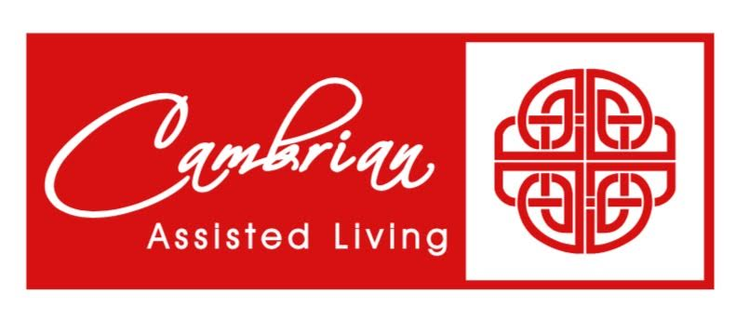 |  |  | 1  9:30 Basketball  1:00 Shuffleboard  2:00 Catholic Rosary  4:00 Happy Hour | 2  9:30 Target Practice &  Daily Chronicle  1:00 Trivia  2:00 Catholic Rosary | 3  9:30 Exercise &  Daily Chronicle  1:00 Game Hour  2:00 Catholic Rosary
4  9:30 Devotion & Music  2:00 Catholic Rosary   | 5  9:30 Noodle Ball Sports &  Daily Chronicle  1:00 Bingo  2:00 Catholic Rosary | 8 Beauty Shop  10:00 Catholic Mass with  Father Stan  1:00 Card Games  2:00 Catholic Rosary  4:00 Happy Hour | 7 Beauty Shop  9:30 Music & Motion &  Daily Chronicle  1:00 Wii Bowling  2:00 Catholic Rosary  3 – 5  Outing to Crumbl Cookie Co | 8  9:30 Basketball  1:00 Shuffleboard  2:00 Catholic Rosary  4:00 Happy Hour & Piano  Entertainment | 9  9:30 Target Practice &  Daily Chronicle  1:00 Trivia  2:00 Catholic Rosary | 10  9:30 Exercise &  Daily Chronicle  1:00 Game Hour  2:00 Catholic Rosary
11  9:30 Devotion & Music  2:00 Catholic Rosary | 12  9:30 Noodle Ball Sports &  Daily Chronicle  1:00 Bingo  2:00 Catholic Rosary  3:00 Book Club | 13 Beauty Shop  9:30 Bean Bag Toss  1:00 America Says  2:00 Catholic Rosary  4:00 Happy Hour | 14 Beauty Shop  9:30 Music & Motion &  Daily Chronicle  10:15 Communion Service  1:00 Wii Bowling  2:00 Catholic Rosary | 15  9:30 Basketball  1:00 Shuffleboard  2:00 Catholic Rosary  4:00 Happy Hour | 16  9:30 Target Practice &  Daily Chronicle  1:00 Friday Bingo  2:00 Catholic Rosary | 17  10:30 Tai Ji with  Chris  1:00 Game Hour  2:00 Catholic Rosary
18  9:30 Devotion & Music  2:00 Catholic Rosary | 19  9:30 Noodle Ball Sports &  Daily Chronicle  1:00 Bingo  2:00 Catholic Rosary  3:00 Book Club | 8 Beauty Shop  9:30 Cardio Drumming  1:00 Card Games  2:00 Catholic Rosary  4:00 Happy Hour | 21 Beauty Shop  9:30 Music & Motion &  Daily Chronicle  10:15 Communion Service  1:00 Wii Bowling  2:00 Catholic Rosary | 22  9:30 Basketball  1:00 Craft Hour  2:00 Catholic Rosary  4:00 Happy Hour & Live  Marimba Music | 23  9:30 Target Practice &  Daily Chronicle  Cambrian Picnic  1:00 Trivia  2:00 Catholic Rosary   | 24  9:30 Exercise &  Daily Chronicle  1:00 Game Hour  2:00 Catholic Rosary
25  9:30 Devotion & Music  2:00 Catholic Rosary | 26  9:30 Noodle Ball Sports &  Daily Chronicle  1:00 Bingo & Resident  Council  2:00 Catholic Rosary  3:00 Book Club | 27 Beauty Shop  9:30 Bean Bag Toss  1:00 America Says  2:00 Catholic Rosary  4:00 Happy Hour | 28 Beauty Shop  9:30 Music & Motion &  Daily Chronicle  10:15 Communion Service  1:00 Wii Bowling  2:00 Catholic Rosary | 29  9:30 Basketball  1:00 Cambrian Store  2:00 Catholic Rosary  4:00 Happy Hour | 30  9:30 Target Practice &  Daily Chronicle  1:00 Trivia  2:00 Catholic Rosary | 31  9:30 Exercise &  Daily Chronicle  1:00 Game Hour  2:00 Catholic Rosary
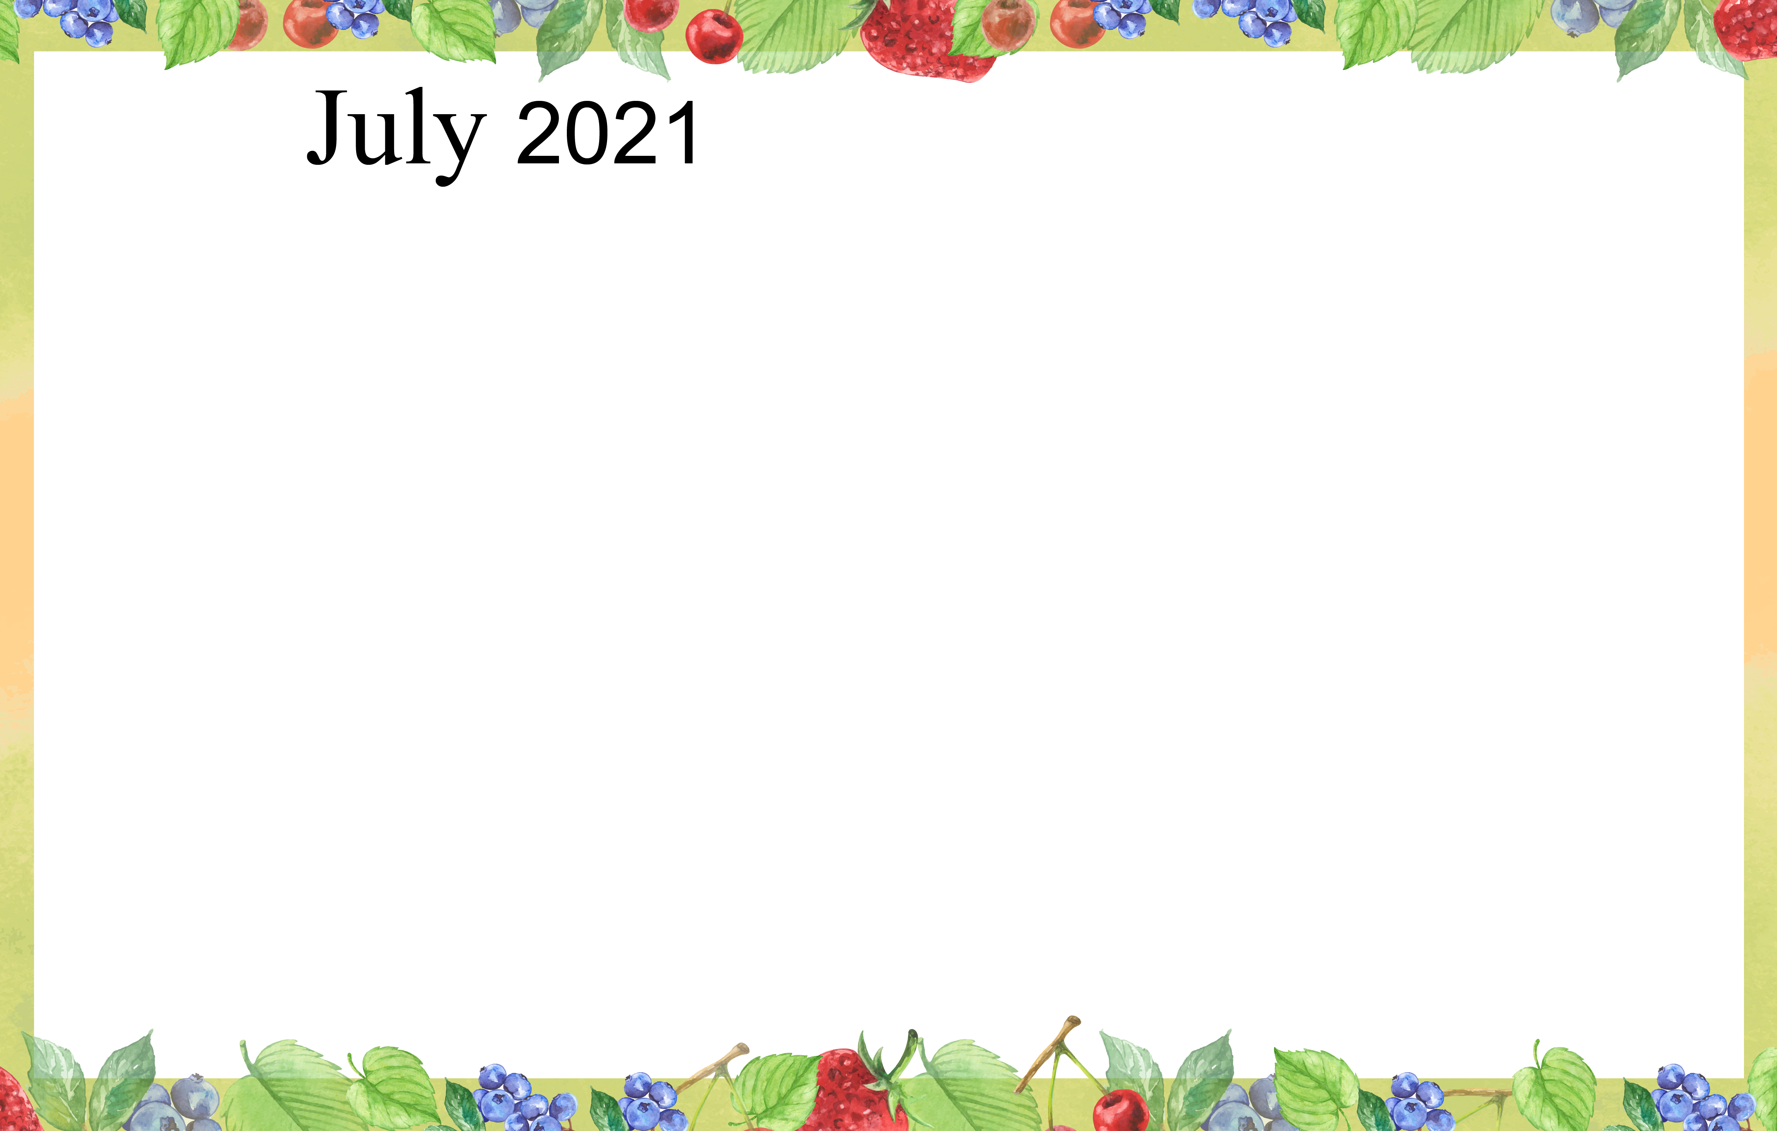
SUNDAY MONDAY TUESDAY WEDNESDAY THURSDAY FRIDAY SATURDAY

