
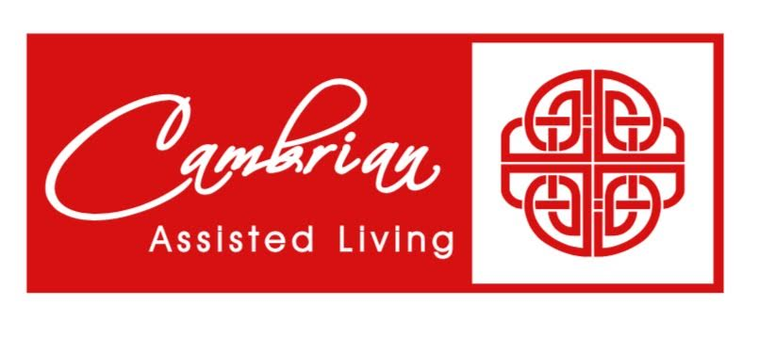 |  | 1 Beauty Shop  9:30 Bean Bag Toss  1:00 America Says  2:00 Catholic Rosary  4:00 Happy Hour |  | 2 Beauty Shop  9:30 Music & Motion &  Daily Chronicle  1:00 Wii Bowling  2:00 Catholic Rosary |  | 3  9:30 Basketball  1:00 Shuffleboard  2:00 Catholic Rosary  4:00 Happy Hour | 4  9:30 Target Practice &  Daily Chronicle  1:00 Trivia  2:00 Catholic Rosary | 5  9:30 Exercise &  Daily Chronicle  1:00 Game Hour  2:00 Catholic Rosary
6  9:30 Devotion, Music &  Communion  2:00 Catholic Rosary | 7  9:30 Noodle Ball Sports &  Daily Chronicle  1:00 Bingo  2:00 Catholic Rosary  3:00 Book Club |  | 8 Beauty Shop  9:30 Cardio Drumming  1:00 Craft Hour  2:00 Catholic Rosary  4:00 Happy Hour |  | 9 Beauty Shop  9:30 Music & Motion &  Daily Chronicle  1:00 Wii Bowling  2:00 Catholic Rosary | 10  9:30 Basketball  1:00 Travelogue: Jamaica  & All about Orchids  2:00 Catholic Rosary  4:00 Happy Hour | 11  9:30 Target Practice &  Daily Chronicle  1:00 Trivia  2:00 Catholic Rosary | 12  9:30 Exercise &  Daily Chronicle  1:00 Game Hour  2:00 Catholic Rosary
13  9:30 Devotion & Music  2:00 Catholic Rosary | 14  9:30 Cardio Crunch &  Daily Chronicle  1:00 Bingo  2:00 Catholic Rosary  3:00 Book Club |  | 15 Beauty Shop  9:30 Bean Bag Toss  1:00 America Says  2:00 Catholic Rosary  4:00 Happy Hour |  | 16 Beauty Shop  9:30 Music & Motion &  Daily Chronicle  1:00 Wii Bowling  2:00 Catholic Rosary  3:00 Out & About:  Guernsey Dairy | 17  9:30 Basketball  Noon: Father’s Day  Picnic  1:00 Cranium Crunch  Puzzles  2:00 Catholic Rosary  4:00 Happy Hour | 18  9:30 Target Practice &  Daily Chronicle  1:00 Trivia  2:00 Catholic Rosary | 19  9:30 Exercise &  Daily Chronicle  1:00 Game Hour  2:00 Catholic Rosary
20 Happy Father’s Day  9:30 Devotion, Music &  Communion  2:00 Catholic Rosary | 21  9:30 Noodle Ball Sports &  Daily Chronicle  1:00 Bingo  2:00 Catholic Rosary  3:00 Book Club |  | 22 Beauty Shop  9:30 Cardio Drumming  1:00 Card Games  2:00 Catholic Rosary  4:00 Happy Hour |  | 23 Beauty Shop  9:30 Music & Motion &  Daily Chronicle  10:00 Cooking Club:  Tapioca Pudding  1:00 Wii Bowling  2:00 Catholic Rosary | 24  9:30 Basketball  1:00 Cambrian Store  2:00 Catholic Rosary  4:00 Happy Hour | 25  9:30 Target Practice &  Daily Chronicle  1:00 Friday Bingo  2:00 Catholic Rosary | 26  9:30 Exercise &  Daily Chronicle  1:00 Game Hour  2:00 Catholic Rosary
27  9:30 Devotion & Music  2:00 Catholic Rosary | 28  9:30 Cardio Crunch &  Daily Chronicle  1:00 Bingo & Resident  Council  2:00 Catholic Rosary  3:00 Book Club |  | 29 Beauty Shop  9:30 Bean Bag Toss  1:00 America Says  2:00 Catholic Rosary  4:00 Happy Hour |  | 30 Beauty Shop  9:30 Music & Motion &  Daily Chronicle  1:00 Wii Bowling  2:00 Catholic Rosary
SUNDAY MONDAY TUESDAY WEDNESDAY THURSDAY FRIDAY SATURDAY

