-
1 |  | 2 |  | 3 |  |  |  | 1  9:30 Basketball & Daily  Chronicle  1:00 Tigers Baseball
 | 3  10:00 Cardio Crunch  1:00 Bingo  4:00 Travelogue to  Georgia |  | 4  Chocolate Chip Cookie Day  10:00 Bean Bag Toss  1:00 Courtyard Games  4:00 Happy Hour |  | 5  10:00 Music & Motion  1:00 Wii Bowling  2:30 Courtyard Music from  Jim Quales | 6  10:00 Basketball  1:00 I Love  4:00 Happy Hour | 7  10:00 Target Practice  1:00 Friday Bingo  4:00 | 8  9:30 Noodle Ball Sports  1:00 Who, What, When
9 | 10  10:00 Noodle Ball Sports  1:00 Bingo  4:00 Music & Prayer |  | 11  10:00 Bean Bag Toss  1:00 Courtyard Games  4:00 Happy Hour |  | 12  10:00 Music & Motion  1:00 Wii Bowling  3:00 | 13  10:00 Basketball  1:00 Game Show Hour  4:00 Happy Hour | 14  9:00 Daily Chronicle  9:30 Target Practice  1:00 Trivia | 15  9:30 Basketball  1:00 Cranium Crunch
16 | 17  10:00 Cardio Crunch  1:00 Bingo  4:00 Let’s Laugh |  | 18  10:00 Bean Bag Toss  1:00 Courtyard Games  4:00 Happy Hour |  | 19  10:00 Music & Motion  1:00 Wii Bowling  3:00 | 20  10:00 Basketball  1:00 Game Show Hour  4:00 Happy Hour | 21  10:00 Target Practice  1:00 Craft Hour  4:00 Trivia | 22  9:30 Noodle Ball Sports  1:00
23 | 24  10:00 Noodle Ball Sports  1:00 Bingo  4:00 Music & Prayer |  | 25  10:00 Bean Bag Toss  1:00 Courtyard Games  4:00 Happy Hour |  | 10:00 Music & Motion  1:00 Wii Bowling  3:00 | 27  10:00 Basketball  1:00 Cambrian Store  4:00 Happy Hour
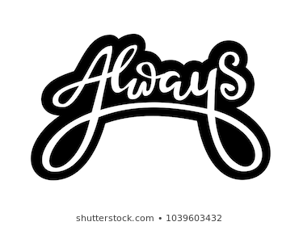30 | 31  10:00 Cardio Crunch  1:00 Bingo
SUNDAY MONDAY TUESDAY WEDNESDAY THURSDAY FRIDAY SATURDAY

