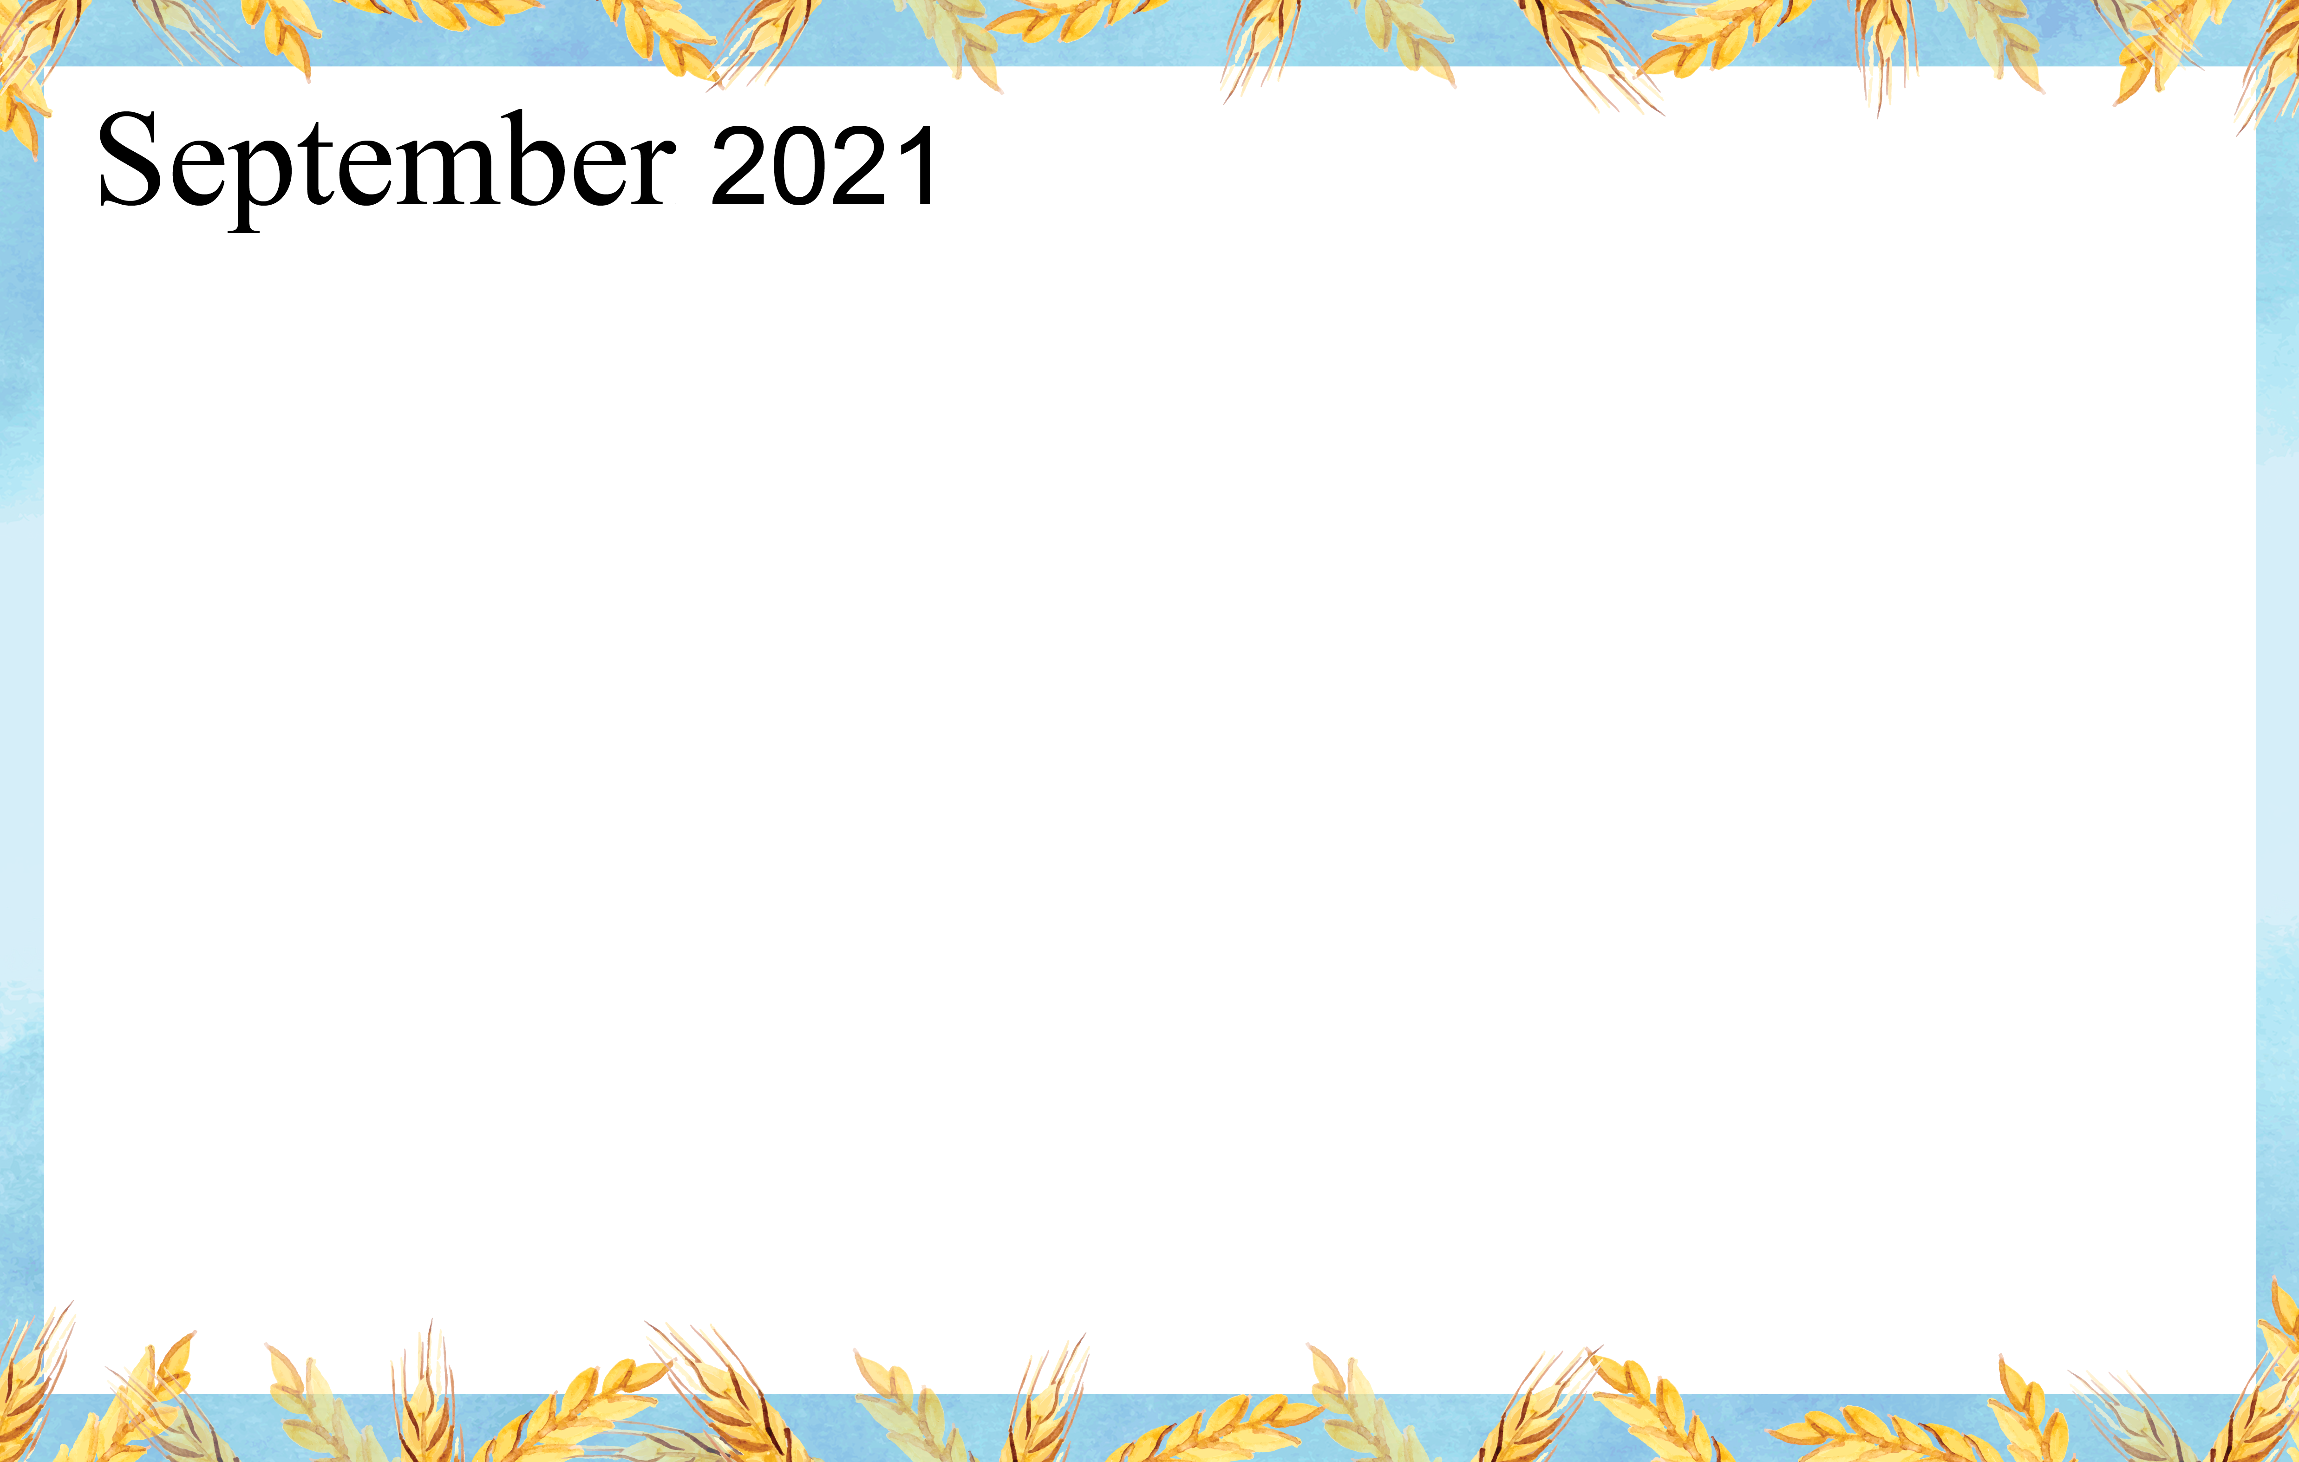
 |  |  | 1  9:30 Music & Motion &  Daily Chronicle  1:00 Wii Bowling  2:00 Catholic Rosary | 2  9:30 Basketball  1:00 Wheel of Fortune  2:00 Catholic Rosary  4:00 Happy Hour |  | 3  9:30 Target Practice &  Daily Chronicle  1:00 Trivia  2:00 Catholic Rosary | 4  9:30 Morning  Movement  1:00 Game Hour  2:00 Catholic  Rosary
5  9:30 Devotion & Music  2:00 Catholic Rosary | 6  9:30 Cardio Crunch &  Daily Chronicle  1:00 Bingo  2:00 Catholic Rosary  3:00 Book Club | 7 Beauty Shop  10:00 Catholic Mass  1:00 Card Games  2:00 Catholic Rosary  4:00 Happy Hour | 8  9:30 Music & Motion &  Daily Chronicle  1:00 Wii Bowling  2:00 Catholic Rosary | 9  9:30 Basketball  1:00 Shuffleboard  2:00 Catholic Rosary  4:00 Happy Hour |  | 10  9:30 Daily Chronicle &  Tai Ji  1:00 Trivia  2:00 Catholic Rosary | 11  9:30 Morning  Movement  1:00 Game Hour  2:00 Catholic  Rosary
12  9:30 Devotion & Music  2:00 Catholic Rosary | 13  9:30 Noodle Ball Sports &  Daily Chronicle  1:00 Bingo  2:00 Catholic Rosary  3:00 Book Club | 14 Beauty Shop  9:30 Bean Bag Toss  1:00 America Says  2:00 Catholic Rosary  4:00 Happy Hour – | 15  9:30 Music & Motion &  Daily Chronicle  10:15 Communion Service  2:00 Catholic Rosary | 16  9:30 Basketball  1:00 Wheel of Fortune  2:00 Catholic Rosary  4:00 Happy Hour |  | 17  9:30 Target Practice &  Daily Chronicle  1:00 Trivia  2:00 Catholic Rosary  4:30 Dinner  5 – 7  Annual Classic Car Show | 18  9:30 Morning  Movement  1:00 Game Hour  2:00 Catholic  Rosary
19  9:30 Devotion & Music  2:00 Catholic Rosary | 20  9:30 Cardio Crunch &  Daily Chronicle  1:00 Bingo  2:00 Catholic Rosary  3:00 Book Club | 21 Beauty Shop  9:30 Cardio Drumming  1:00 Wheel of Fortune  2:00 Catholic Rosary  4:00 Happy Hour | 22  9:30 Music & Motion &  Daily Chronicle  10:15 Communion Service  1:00 Wii Bowling  2:00 Catholic Rosary | 23  9:30 Beachball  1:00 Cambrian Store  2:00 Catholic Rosary  4:00 Happy Hour & Piano  Entertainment |  | 24  9:30 Target Practice &  Daily Chronicle  1:00 Trivia  2:00 Catholic Rosary | 25  9:30 Morning  Movement  1:00 Game Hour  2:00 Catholic  Rosary
26  9:30 Devotion & Music  2:00 Catholic Rosary | 27  9:30 Noodle Ball Sports &  Daily Chronicle  1:00 Bingo & Resident  Council  2:00 Catholic Rosary  3:00 Book Club | 28 Beauty Shop  9:30 Bean Bag Toss  1:00 Card Games  2:00 Catholic Rosary  4:00 Happy Hour | 29  9:30 Music & Motion &  Daily Chronicle  10:15 Communion Service  1:00 Wii Bowling  2:00 Catholic Rosary | 30  9:30 Basketball  1:00 Wheel of Fortune  2:00 Catholic Rosary  4:00 Happy Hour | 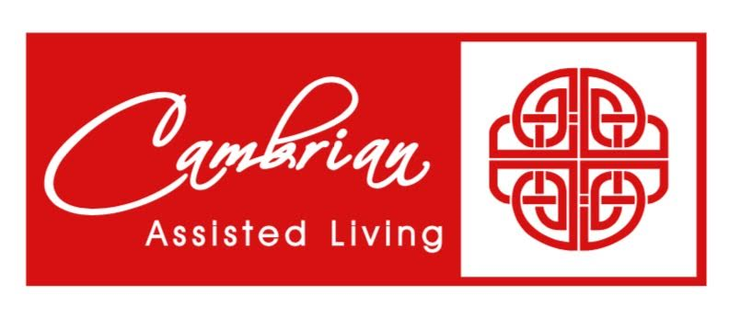
SUNDAY MONDAY TUESDAY WEDNESDAY THURSDAY FRIDAY SATURDAY

