Sunday | Monday | Tuesday | Wednesday | Thursday | Friday | Saturday
 |  |  |  |  | 1 | 2
3 | 4 | 5 | 6 | 7 | 8 | 9
10 | 11  Columbus Day (US)  Indigenous Peoples’ Day  Thanksgiving (Canada) | 12 | 13 | 14 | 15 | 16
17 | 18 | 19 | 20 | 21 | 22 | 23
24 | 25 | 26 | 27 | 28 | 29 | 30
31

Halloween

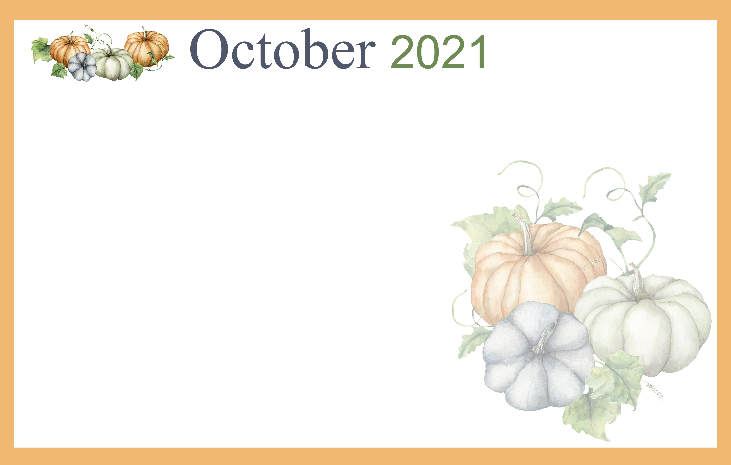 |  |  |  |  | 9:30 Target Practice &  Daily Chronicle  1:00 Coffee Trivia  2:00 Catholic Rosary | #ENDALZWALK  WEAR PURPLE!  9:30 Morning  Movement  11:00 UofM Football  1:00 Game Hour  2:00 Catholic Rosary
9:30 Devotion & Music  2:00 Catholic Rosary | 9:30 Cardio Crunch &  Daily Chronicle  1:00 Bingo  2:00 Catholic Rosary  3:00 Book Club | Beauty Shop  10:00 Catholic Mass  1:00 Card Games  2:00 Catholic Rosary  4:00 Happy Cooking Hour  Apple Betty Day | 9:30 Music & Motion &  Daily Chronicle  1:00 Out & About –  Erwins Orchards  2:00 Catholic Rosary | 9:30 Basketball  1:00 Wheel of Fortune  2:00 Catholic Rosary  4:00 Happy Hour | 9:30 Ring Toss &  Daily Chronicle  1:00 Drum Circle  2:00 Catholic Rosary | Silly Sneaker Day-wear  mismatched shoes  9:30 Morning  Movement  NOON UofM Football  1:00 Game Hour  2:00 Catholic Rosary
9:30 Devotion & Music  2:00 Catholic Rosary | 9:30 Noodle Ball Sports &  Daily Chronicle  1:00 Bingo  2:00 Catholic Rosary  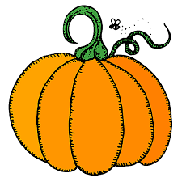  3:00 Book Club | Beauty Shop  9:30 Bean Bag Toss  1:00 America Says  2:00 Catholic Rosary  4:00 Happy Cooking Hour  Pumpkin Dip | 9:30 Music & Motion &  Daily Chronicle  10:15 Communion Service  1:00 Wii Bowling  2:00 Catholic Rosary | 9:30 Basketball  1:00 Shuffleboard  2:00 Catholic Rosary  4:00 Happy Poland Hour  Pierogies | 9:30 Bowling &  Daily Chronicle  1:00 Trivia  2:00 Catholic Rosary | Scarecrow Saturday  9:30 Morning  Movement  NOON MSU Football  1:00 Game Hour/Craft  2:00 Catholic Rosary
9:30 Devotion & Music  2:00 Catholic Rosary | 9:30 Cardio Crunch &  Daily Chronicle  1:00 Bingo  2:00 Catholic Rosary  3:00 Book Club | Beauty Shop  10:00 Tai Ji  1:00 Wheel of Fortune  2:00 Catholic Rosary  4:00 Happy Hour | 9:30 Music & Motion  & Daily Chronicle  10:15 Communion Service  1:00 Wii Bowling  2:00 Catholic Rosary | 9:30 Basketball  1:00 Cambrian Store  2:00 Catholic Rosary  4:00 Happy Craft Hour  Pumpkins & Signs | PINK OUT!  WEAR PINK FOR BREAST  CANCER AWARENESS  9:30 Target Practice &  Daily Chronicle  1:00 Trivia  2:00 Catholic Rosary | 9:30 Morning  Movement  1:00 UofM Football  1:00 Game Hour  2:00 Catholic Rosary
Halloween Spirit Week  9:30 Devotion & Music  2:00 Catholic Rosary | Wear Orange  9:30 Noodle Ball Sports &  Daily Chronicle  1:00 Bingo  2:00 Catholic Rosary  No book club today! | Beauty Shop  Witch or Wizard Day  9:30 Bean Bag Toss  1:00 Card Games &  Resident Council  2:00 Catholic Rosary  4:00 Happy Hour  Halloween Mad Lib | Halloween Gear  9:30 Monster Mash Motion  & Daily Chronicle  10:15 Communion Service  1:00 Wii Bowling  2:00 Catholic Rosary | Costume Contest  9:30 Basketball  1:00 Halloween Party  2:00 Catholic Rosary  4:00 Happy Hour | 9:30 Ring Toss &  Daily Chronicle  1:00 Trivia  2:00 Catholic Rosary | 9:30 Morning  Movement  TBD UofM vs MSU  1:00 Game Hour  2:00 Catholic Rosary
Happy Halloween!  9:30 Devotion & Music  2:00 Catholic Rosary | 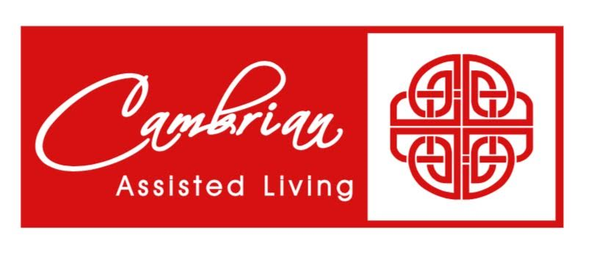    Mo October 2  Ron C. October 17  Shirley October 23
Cambrian Senior Living 52365 10 Mile Road South Lyon Mi 48178

