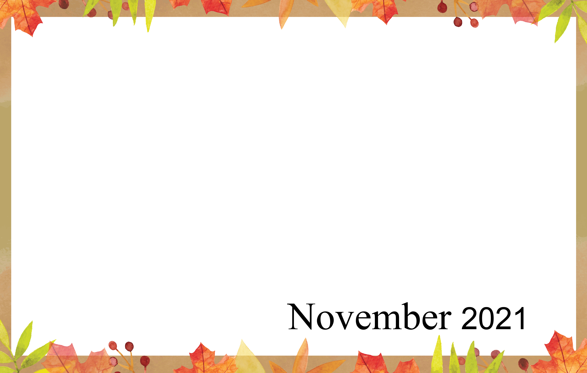
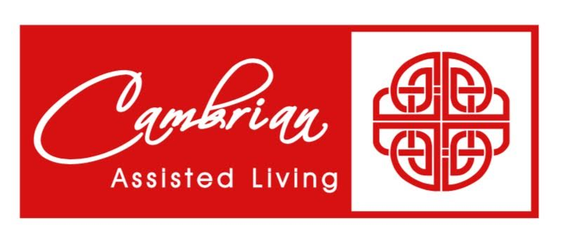 | 1  9:30 Noodle Ball Sports &  Daily Chronicle  1:00 Bingo  2:00 Catholic Rosary  3:00 Book Club | 2 Election Day  Beauty Shop  10:00 Catholic Mass  1:00 Card Games  2:00 Catholic Rosary  4:00 Happy Hour | 3  9:30 Music & Motion &  Daily Chronicle  2:00 Flu & Booster Clinic  4:00 Catholic Rosary | 4  9:30 Basketball  1:00 Wheel of Fortune  2:00 Catholic Rosary  4:00 Happy Hour &  Entertainment- The  Howling Ukuladies | 5  9:30 Bowling &  Daily Chronicle  1:00 Trivia  2:00 Catholic Rosary | 6  9:30 Morning  Movement  1:00 Game Hour-  Family Feud  2:00 Catholic  Rosary
7 Daylight Savings  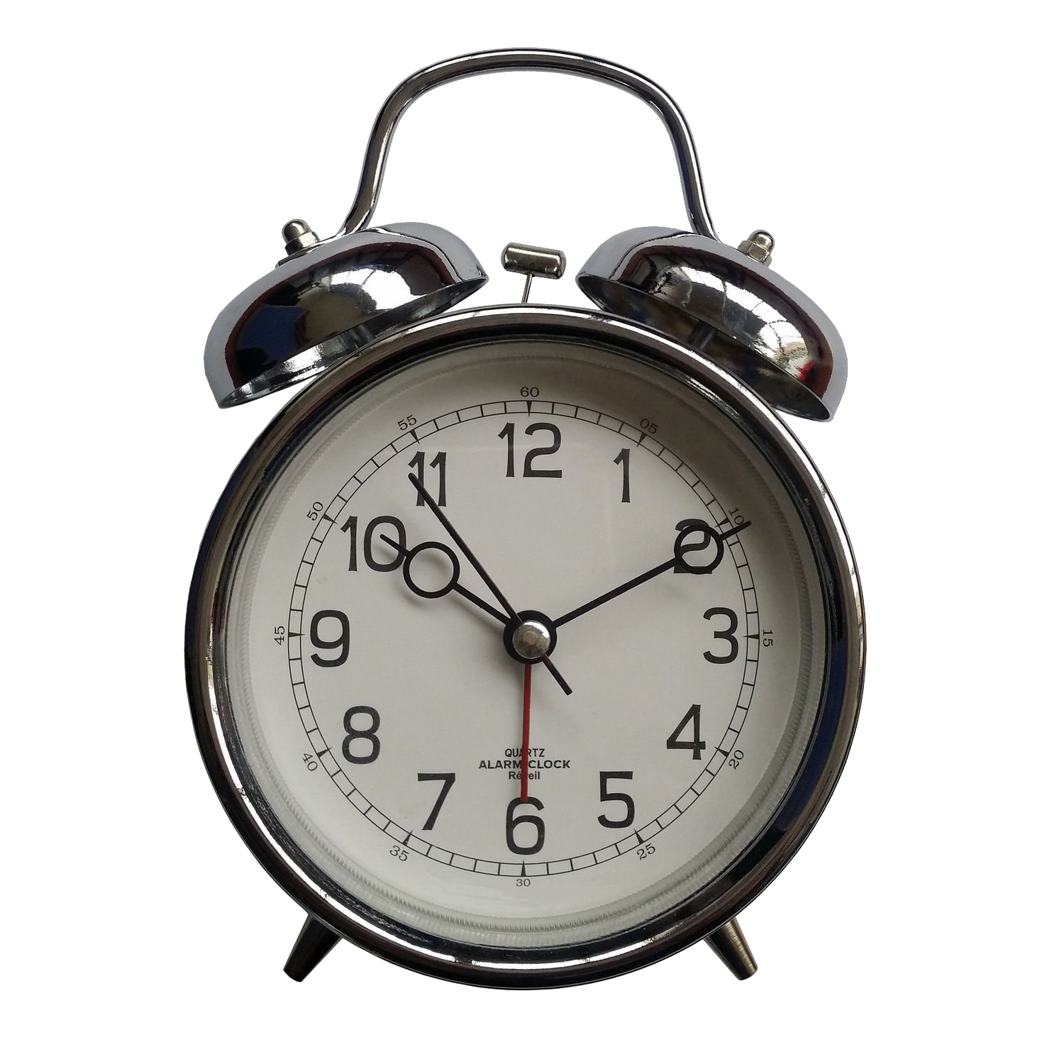  9:30 Devotion & Music  2:00 Catholic Rosary | 8  9:30 Cardio Crunch &  Daily Chronicle  1:00 Bingo  2:00 Catholic Rosary  3:00 Book Club | 9 Beauty Shop  10:00 Walking Club  1:00 Card Games  2:00 Catholic Rosary  4:00 Happy Cooking Hour  Peanut Butter Cookies | 10  9:30 Music & Motion &  Daily Chronicle  10:00 Communion Service  1:00 Wii Bowling  2:00 Catholic Rosary | 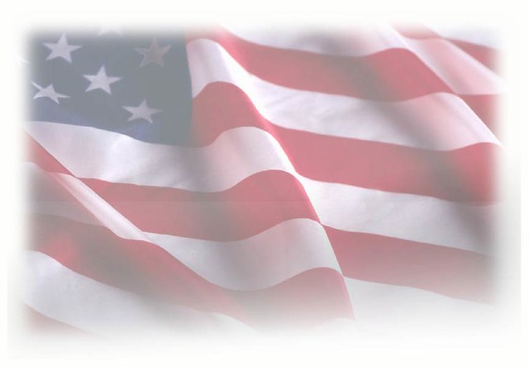  11 Veterans Day  9:30 Basketball  1:00 Shuffleboard  2:00 Catholic Rosary  4:00 Happy Hour – Honoring our Veterans | 12  9:30 Ring Toss &  Daily Chronicle  1:00 Drum Circle  2:00 Catholic Rosary | 13 Random Acts of  Kindness Day  9:30 Morning  Movement  1:00 Game Hour  2:00 Catholic  Rosary
14  9:30 Devotion & Music  2:00 Catholic Rosary | 15  9:30 Noodle Ball Sports &  Daily Chronicle  1:00 Bingo  2:00 Catholic Rosary  3:00 Book Club-Puzzle  bookmarks | 16 Beauty Shop  10:00 Time for Tai Ji  1:00 America Says  2:00 Catholic Rosary  4:00 Happy Craft Hour –  Cork Pumpkins | 17  9:30 Music & Motion &  Daily Chronicle  10:15 Communion Service  & Heart of the Nation  1:00 Wii Bowling  2:00 Catholic Rosary | 18  9:30 Basketball  1:00 Cambrian Store  2:00 Catholic Rosary  4:00 Happy Hour | 19  9:30 Target Practice &  Daily Chronicle  1:00 Trivia  2:00 Catholic Rosary | 20  9:30 Morning  Movement  1:00 Game Hour  2:00 Catholic  Rosary
21  9:30 Devotion & Music  2:00 Catholic Rosary | 22  9:30 Cardio Crunch &  Daily Chronicle  1:00 Bingo  2:00 Catholic Rosary  3:00 Book Club | 23 Beauty Shop  9:30 Cardio Drumming  1:00 Wheel of Fortune  2:00 Catholic Rosary  4:00 Happy Hour &  Entertainment-  Steve Mullan | 24  9:30 Music & Motion &  Daily Chronicle  10:00 Communion Service  1:00 Spa Day  2:00 Catholic Rosary | 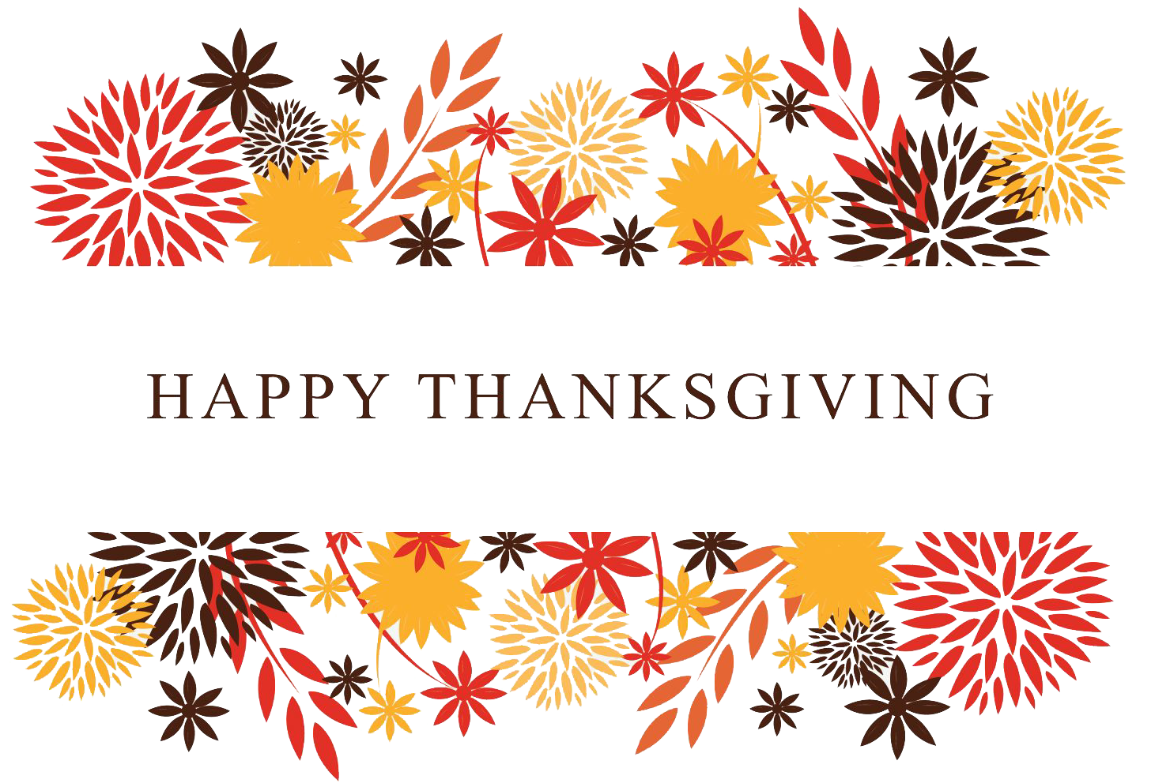  25 | 26  9:30 Walking Club &  Daily Chronicle  1:00 Trivia  2:00 Catholic Rosary | 27  9:30 Morning  Movement  1:00 Game Hour  2:00 Catholic  Rosary
28  9:30 Devotion & Music  2:00 Catholic Rosary | 29  9:30 Noodle Ball Sports &  Daily Chronicle  1:00 Bingo & Resident  Council  2:00 Catholic Rosary  3:00 Book Club | 30 Beauty Shop  9:30 Bean Bag Toss  1:00 Out & About  2:00 Catholic Rosary  4:00 Happy Hour
SUNDAY MONDAY TUESDAY WEDNESDAY THURSDAY FRIDAY SATURDAY

