 |  |  | 1  9:30 Music & Motion &  Daily Chronicle  1:00 Wii Bowling  2:00 Catholic Rosary | 2  9:30 Basketball  Noon: Resident Holiday  Luncheon  1:15 Resident Holiday  Party & Entertainment | 4  9:30 Target Practice &  Daily Chronicle  1:00 Trivia  2:00 Catholic Rosary |  | 4  9:30 Joyous  Movement  1:00 Game Hour  2:00 Catholic  Rosary
5  9:30 Devotion & Music  2:00 Catholic Rosary | 6  9:30 Cardio Crunch &  Daily Chronicle  1:00 Bingo  2:00 Catholic Rosary  3:00 Book Club | 7 Beauty Shop  10:00 Catholic Mass  1:00 Card Games  2:00 Catholic Rosary  4:00 Happy Craft Hour –  Marble Ornaments | 8  9:30 Music & Motion &  Daily Chronicle  1:00 Wii Bowling  2:00 Catholic Rosary &  communion | 9  9:30 Basketball  1:00 Shuffleboard  2:00 Catholic Rosary  4:00 Happy Hour –  SLEHS Choir | 10  9:30 Target Practice &  Daily Chronicle  1:00 Drum Circle  2:00 Catholic Rosary |  | 11  9:30 Morning  Movement  1:00 Game Hour  2:00 Catholic  Rosary  ”
12  9:30 Devotion & Music  2:00 Catholic Rosary | 13  9:30 Noodle Ball Sports  & Daily Chronicle  1:00 Bingo  2:00 Catholic Rosary  3:00 Book Club | 14 Beauty Shop  10:00 Walking Club  1:00 Card Games  2:00 Catholic Rosary  4:00 Happy Hour –  Ornament Craft | 15  9:30 Music & Motion &  Daily Chronicle  10:00 Communion Service  1:00 Wii Bowling  2:00 Catholic Rosary  5:00 Out and About  Christmas Lights & Pizza | 16  10:00 Basketball  1:00 Cambrian Store  2:00 Rosary  4:00 Happy Hour | 17 Ugly Sweater Day  9:30 Target Practice &  Daily Chronicle  1:00 Friday Bingo  2:00 Catholic Rosary  ” |  | 18  9:30 Morning  Movement  1:00 Game Hour  Saran Wrap Ball  Game  2:00 Catholic  Rosary
19  9:30 Devotion & Music  2:00 Catholic Rosary | 20 Christmas Sock Day  9:30 Cardio Crunch &  Daily Chronicle  1:00 Bingo  2:00 Catholic Rosary  3:00 Book Club | 21 Beauty Shop  Santa hat, holiday headbands, elf attire day  10:00 Time for Tai Ji  1:00 Spa Day  2:00 Catholic Rosary  4:00 Happy Hour &  Special Guests | 22 PJ day  9:30 Music & Motion &  Daily Chronicle  10:00 Communion Service & Heart of the Nation Mass  1:00 Wii Bowling  2:00 Catholic Rosary | 23 Merry Grinchmas  Wear green  9:30 Passport for Wellness  1:00 Left, Right Center gift  game  2:00 Catholic Rosary  4:00 Happy Hour –  How the Grinch stole  Christmas | 24  1:00 Christmas Eve  Service  2:00 Catholic Rosary |  | 25  
26 PJ Day  9:30 Devotion & Music  2:00 Catholic Rosary | 27  9:30 Noodle Ball Sports & Daily Chronicle  1:00 Bingo  2:00 Catholic Rosary  3:00 Book Club | 28 Beauty Shop  10:00 Walking Club  1:00 Card Games  2:00 Catholic Rosary  4:00 Happy Hour | 29  9:30 Music & Motion &  Daily Chronicle  1:00 Wii Bowling  2:00 Catholic Rosary | 30  9:30 Basketball  1:00 shuffleboard  2:00 Catholic Rosary  4:00 Happy Hour | 31  9:30 NYE Exercise  12:00 NYE Toast & Party  2:00 Catholic Rosary |   
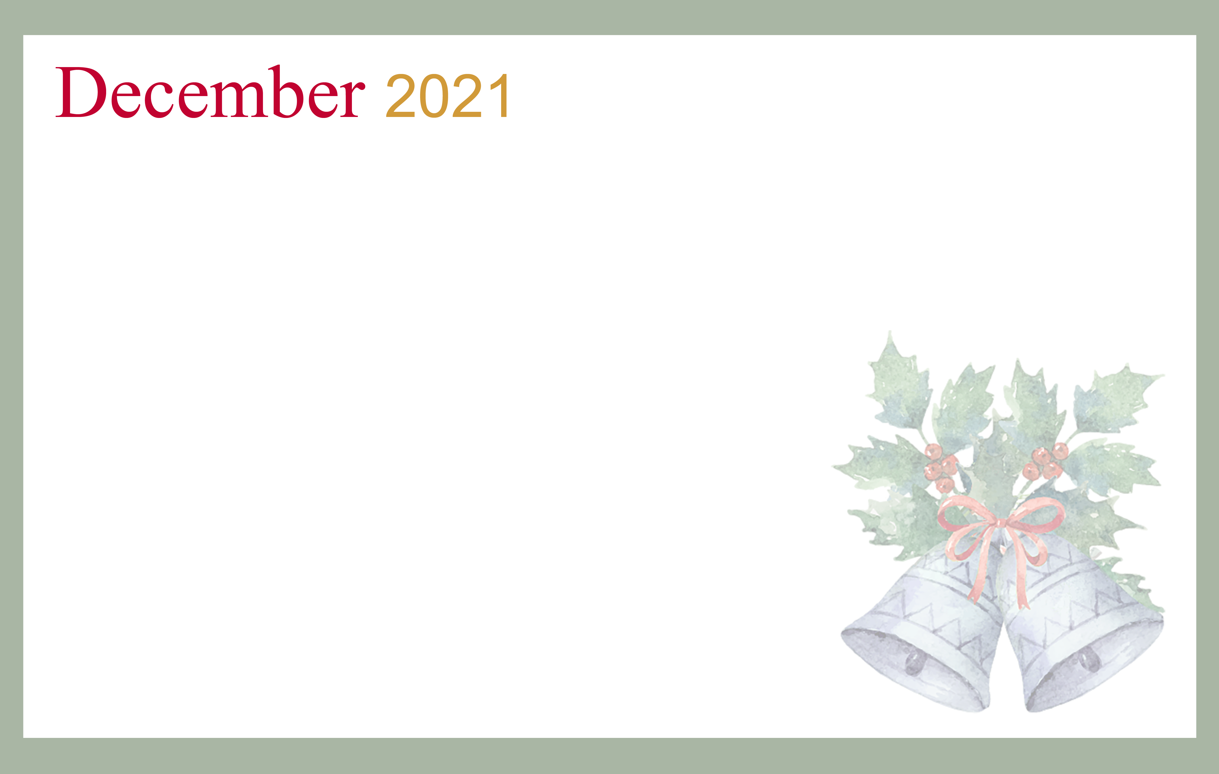
SUNDAY MONDAY TUESDAY WEDNESDAY THURSDAY FRIDAY SATURDAY
Cambrian Senior Living *52365 10 Mile Rd. * South Lyon, MI 48178 * www.cambrianseniorliving.com * Like us on Facebook

