
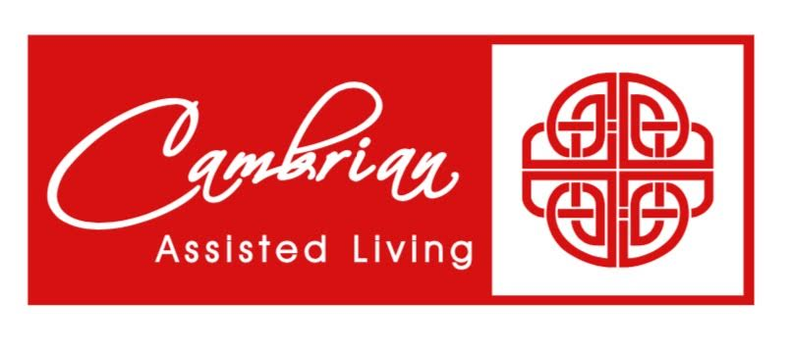 |  |  |  |  |  |  | 1  9:30 Morning  Movement  1:00 Game Hour  2:00 Catholic  Rosary
2  9:30 Devotion & Music  2:00 Catholic Rosary | 3  9:30 Cardio Crunch &  Daily Chronicle  1:00 Bingo  2:00 Catholic Rosary | 4 Beauty Shop  10:00 Catholic Mass  1:00 Card Games  2:00 Catholic Rosary  4:00 Happy Hour-  Entertainment | 5  9:30 Music & Motion &  Daily Chronicle  1:00 Wii Bowling  2:00 Catholic Rosary | 6  9:30 Basketball  1:00 Shuffleboard  2:00 Catholic Rosary  4:00 Happy Cooking Hour -  Banana Bread |  | 7  9:30 Daily Chronicle &  Tai Ji  1:00 Trivia  2:00 Catholic Rosary | 8  9:30 Morning  Movement  1:00 Game Hour  2:00 Catholic  Rosary
9  9:30 Devotion & Music  2:00 Catholic Rosary | 10  9:30 Noodle Ball Sports &  Daily Chronicle  1:00 Bingo & Resident Council  2:00 Catholic Rosary | 11 Beauty Shop  9:30 Bean Bag Toss  1:00 America Says  2:00 Catholic Rosary  4:00 Happy Hour – Birdseed Ornaments & paper lanterns | 12  9:30 Music & Motion &  Daily Chronicle  1:00 Wii Bowling  2:00 Catholic Rosary | 13  9:30 Basketball  1:00 Wheel of Fortune  2:00 Catholic Rosary  4:00 Happy Hour |  | 14  9:30 Target Practice &  Daily Chronicle  1:00 Friday Bingo  2:00 Catholic Rosary | 15  9:30 Morning  Movement  1:00 Game Hour  2:00 Catholic  Rosary
16  9:30 Devotion & Music  2:00 Catholic Rosary | 17 Martin Luther King Day  9:30 Cardio Crunch &  Daily Chronicle  1:00 Bingo  2:00 Catholic Rosary | 18 Beauty Shop  9:30 Cardio Drumming  1:00 Spa Day  2:00 Catholic Rosary  4:00 Happy Craft Hour | 19  9:30 Music & Motion &  Daily Chronicle  1:00 Wii Bowling  2:00 Catholic Rosary | 20  9:30 Beachball  1:00 Wheel of Fortune  2:00 Catholic Rosary  4:00 Happy Hour |  | 21  9:30 Target Practice &  Daily Chronicle  1:00 Trivia  2:00 Catholic Rosary  3:45 Piano Entertainment | 22  9:30 Morning  Movement  1:00 Game Hour  2:00 Catholic  Rosary
23  9:30 Devotion & Music  2:00 Catholic Rosary | 24  9:30 Noodle Ball Sports  1:00 Bingo  2:00 Catholic Rosary  3:00 Book Club | 25 Beauty Shop  9:30 Bean Bag Toss  1:00 Card Games  2:00 Catholic Rosary    4:00 Happy Hour | 26  9:30 Music & Motion &  Daily Chronicle  1:00 Wii Bowling  2:00 Catholic Rosary  3:00 Out & About | 27  9:30 Basketball  1:00 Cambrian Store  2:00 Catholic Rosary  4:00 Happy Hour | 28  9:30 Target Practice &  Daily Chronicle  1:00 Trivia  2:00 Catholic Rosary |  |  | 29  9:30 Morning Movement  1:00 Game Hour  2:00 Catholic Rosary
30  9:30 Devotion & Music  2:00 Catholic Rosary | 31  9:30 Noodle Ball Sports  1:00 Bingo  2:00 Catholic Rosary | Barb J. 1/7
SUNDAY MONDAY TUESDAY WEDNESDAY THURSDAY FRIDAY SATURDAY

