|  |  |  |  |  |  |  |
| --- | --- | --- | --- | --- | --- | --- |
|  |  |  |  |  |  |  |
| **Memory Care** | | | **9:30** Cardio Drumming  **10:15** Happy Feet  **11:00** Name 5  **1:30** Flower Arranging  **2:30** Snack Time  **3:00 Visits with Max the Wonder Dog**  **6:30** Coloring/Drawing | **9:30** Exercise  **10:15** Fitness Fun  **11:00** Time in the Garden  **1:30** Open Art  **2:30** Happy Hour  **3:30** Ace Bingo  **6:30** Music & Relaxation | **9:30** Exercise  **10:15** Time to Move  **11:00** Word Fun  **1:30** Open Art- Rock Art  **2:30** Snack Time  **3:30** Music in the Garden  **6:30** Movie and Popcorn | **10:00** Morning Movement  **11:00** Reminisce  **1:00** TV classics “The Waltons”  **2:30** Snack Time- Dirt Cups  **6:30** Color/Drawing |
| **10:00** Morning Movement  **11:00** Travelogue  **1:00** Hymn Sing-along  **2:30** Snack Time  **3:30** Game Time  **6:30** Music/Relaxation | **9:30** Exercise  **10:15** Catch and Release  **11:00** Trivia  **1:30** Open Art  **2:30** Snack Time  **3:30** Noodle Ball  **6:30** Movie and Popcorn | **9:30** Exercise  **10:15** Let’s Get Movin’  **11:00** Fishing Fun  **1:30** Open Art  **2:30** Happy Hour  **3:30** Ace Bingo  **6:30** Hand Care | **9:30** Cardio Drumming  **10:15** Happy Feet  **11:00** I Went Fishing….  **1:30** Flower Arranging  **2:30** Snack Time  **3:00 Visits with Max the Wonder Dog**  **6:30** Coloring/Drawing | **9:30** Exercise  **10:15** Fitness Fun  **11:00** Match the Fish  **1:30** Open Art  **2:30** Happy Hour-  **3:30** Ace Bingo  **6:30** Music & Relaxation | **9:30** Exercise  **10:15** Time to Move  **11:00** Word Fun  **1:30** Open Art  **2:30** Snack time- Fish Food  **3:30** Gone Fishing  **6:30** Movie and Popcorn | **10:00** Morning Movement  **11:00** Reminisce  **1:00** Our Planet- Ocean  **2:30** Snack Time  **3:30** Small Groups  **6:30** Color/Drawing |
| **10:00** Morning Movement  **11:00** Travelogue  **1:00** Hymn Sing-along  **2:30** Snack Time  **3:30** Game Time  **6:30** Music/Relaxation | **9:30** Exercise  **10:15** Let’s Get Active  **11:00** Trivia  **1:30** Open Art  **2:30** Snack Time  **3:30** Noodle Ball  **6:30** Movie and Popcorn | **9:30** Exercise  **10:15** Let’s Get Movin’  **11:00** Word Games  **1:30** Flag Folding  **2:30** Happy Hour  **3:30** Ace Bingo  **6:30** Hand Care | **9:30** Cardio Drumming  **10:15** Happy Feet  **11:00** Name 5  **1:30** Flower Arranging  **2:30** Snack Time  **3:00 Visits with Max the Wonder Dog**  **6:30** Coloring/Drawing | **9:30** Exercise  **10:15** Fitness Fun  **11:00** Brain Teasers  **1:30** Open Art  **2:30** Happy Hour  **3:30** Ace Bingo  **6:30** Music & Relaxation | **9:30** Exercise  **10:15** Time to Move  **11:00** Word Fun  **2:00 Father’s Day Floats**  **2:30** Snack Time  **3:30** Balloon Hockey  **6:30** Movie and Popcorn | **10:00** Morning Movement  **11:00** Reminisce  **1:00** TV classics “Andy Griffith Show”  **2:30** Snack Time-Pic Nic Day  **6:30** Color/Drawing |
| **10:00** Morning Movement  **11:00** Travelogue  **1:00** Hymn Sing-along  **2:30** Snack Time  **3:30** Game Time  **6:30** Music/Relaxation | **9:30** Exercise  **10:15** Let’s Get Active  **11:00** Trivia  **1:30** Open Art  **2:30** Snack Time  **3:30** Noodle Ball  **6:30** Movie and Popcorn | **9:30** Exercise  **10:15** Let’s Get Movin’  **11:00** Word Games  **1:30** Open Art  **2:30** Happy Hour  **3:30** Ace Bingo  **6:30** Hand Care | **9:30** Cardio Drumming  **10:15** Out In the Garden  **11:00** Name 5  **1:30** Buzzing Bee Craft  **2:30** Snack Time  **3:00 Visits with Max the Wonder Dog**  **6:30** Coloring/Drawing | **9:30** Exercise  **10:15** Fitness Fun  **11:00** Brain Teasers  **1:30** Open Art  **2:30** Happy Hour  **3:30** Ace Bingo  **6:30** Music & Relaxation | **9:30** Exercise  **10:15** Time to Move  **11:00** Word Fun  **1:30** Open Art  **2:30** Snack Time  **3:30** Balloon Hockey  **6:30** Movie and Popcorn | **1**  **0:00** Morning Movement  **11:00** Reminisce  **1:00** TV classics “I love Lucy”  **2:30** Snack Time  **3:30** Small Groups  **6:30** Color/Drawing |
| **10:00** Morning Movement  **11:00** Travelogue  **1:00** Hymn Sing-along  **2:30** Snack Time  **3:30** Game Time  **6:30** Music/Relaxation | **9:30** Exercise  **10:15** Let’s Get Active  **11:00** Trivia  **1:30** Open Art  **2:30** Snack Time  **3:30** Noodle Ball  **6:30** Movie and Popcorn | **9:30** Exercise  **10:15** Let’s Get Movin’  **11:00** Word Games  **1:30** Open Art  **2:30** Happy Hour  **3:30** Beach Ball Fun  **6:30** Hand Care | **9:30** Cardio Drumming  **10:15** Happy Feet  **11:00** Name 5  **1:30** Hawaiian Leis  **2:30** Snack Time  **3:00 Visits with Max the Wonder Dog**  **6:30** Coloring/Drawing | **9:30** Exercise  **10:15** Fitness Fun  **11:00** Brain Teasers  **1:30** Open Art  **2:30** Happy Hour  **3:30** Ace Bingo  **6:30** Music & Relaxation |  | |

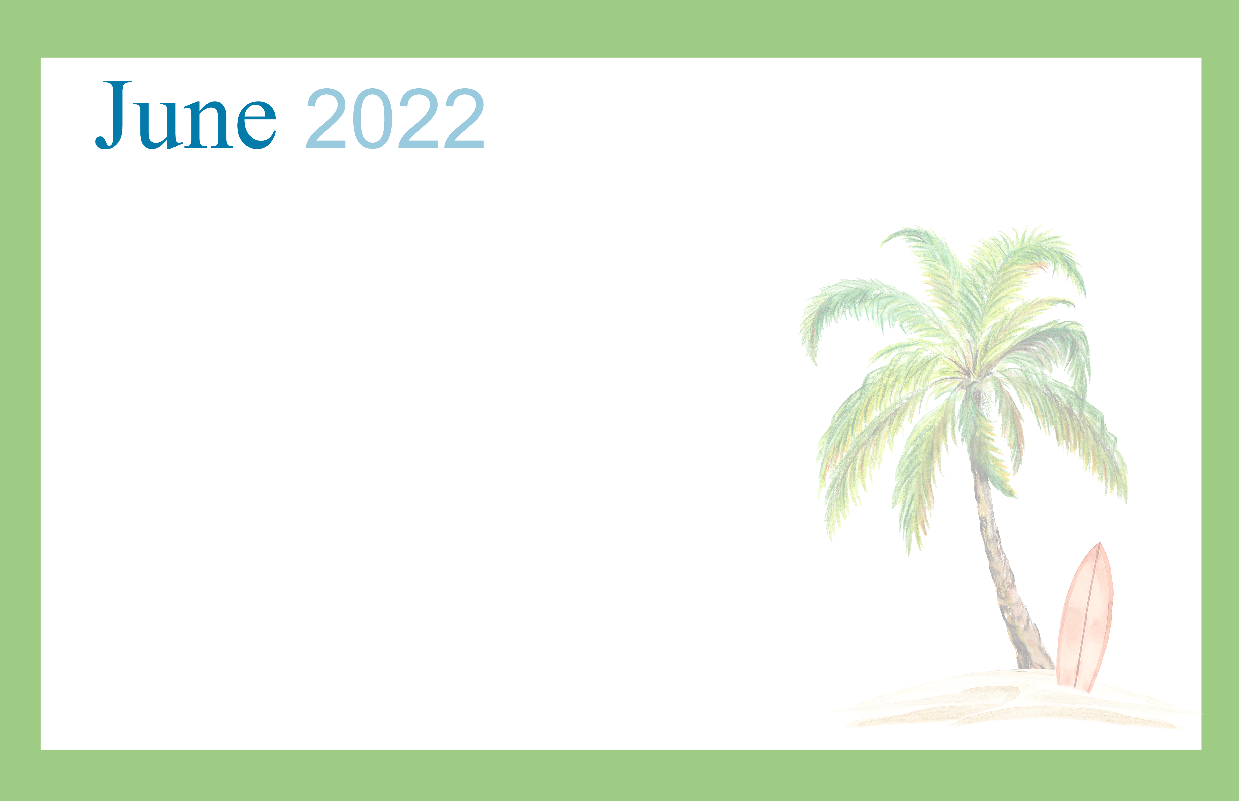 **Cambrian Memory Care & Assisted Living 333 N. Occidental Hwy Tecumseh, MI 49286**

|  |  |  |  |  |  |  |
| --- | --- | --- | --- | --- | --- | --- |
| Sunday | Monday | Tuesday | Wednesday | Thursday | Friday | Saturday |
|  | | | 1 | 2 | 3 | **4** Shavuot Begins |
| **5** | 6 | 7 | 8 | 9 | 10 | 11 |
| 12 | 13 | **14** Flag Day (US) | 15 | 16 | 17 | 18 |
| **19**  Father’s Day Juneteenth | 20 | **21** Summer Begins | 22 | 23 | 24 | 25 |
| 26 | 27 | 28 | 29 | 30 |  | |